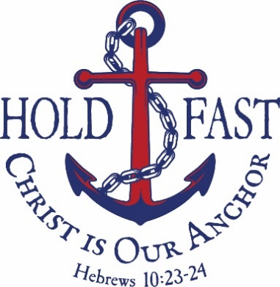

Let us hold fast the confession of our hope without wavering, for he who promised is faithful. And let us consider how to stir up one another to love and good works,
(Hebrews 10:23–24).

Opening Worship

43rd Biennial Convention
Lutheran Women in Mission
Texas District
Corpus Christi, Texas
June 13, 2024
Welcome! We give thanks that our gracious Lord Jesus Christ has gathered us together for His Divine Service. Today again our Lord comes to serve us and lavish us with His gifts of life, forgiveness, and salvation by His Word and Sacrament. In thanksgiving and praise, our hearts and voices are joined in prayer and song with King David: “How lovely is your dwelling place, O LORD of hosts! A day in your courts is better than a thousand elsewhere” (Psalm 84:1–2).

Regarding the Celebration of Holy Communion
Today we receive the Lord’s Supper as guests of our host congregation, Mount Olive Lutheran Church, Corpus Christi, and its pastor, Rev. Kevin Jennings. We thank them for this service on our behalf.

The Lord’s Supper is celebrated at this altar in the confession and glad confidence that, as He says, our Lord gives into our mouths not only bread and wine, but His very body and blood to eat and to drink for the forgiveness of sins and to strengthen our union with Him and with one another. Our Lord invites to His table those who trust His words, repent of all sin, and set aside any refusal to forgive and love as He forgives and loves us, that they may show forth His death until He comes. Because those who eat and drink our Lord’s body and blood unworthily do so to their great harm and because Holy Communion is a confession of the faith which is confessed at this altar, any who are not yet instructed, in doubt, or who hold a confession differing from that of The Lutheran Church—Missouri Synod, and yet desire to receive the Sacrament, are asked first to speak with the pastor of the host congregation.

Pre-Service Music

"I Will Wait For You"

"The Lord is My Salvation"

"He Will Hold Me Fast"

"Jesus Shall Reign"

Processional Hymns

913 O Holy Spirit, Enter In
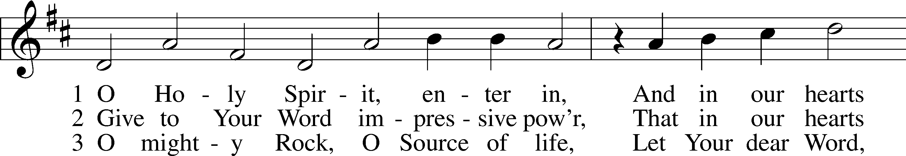
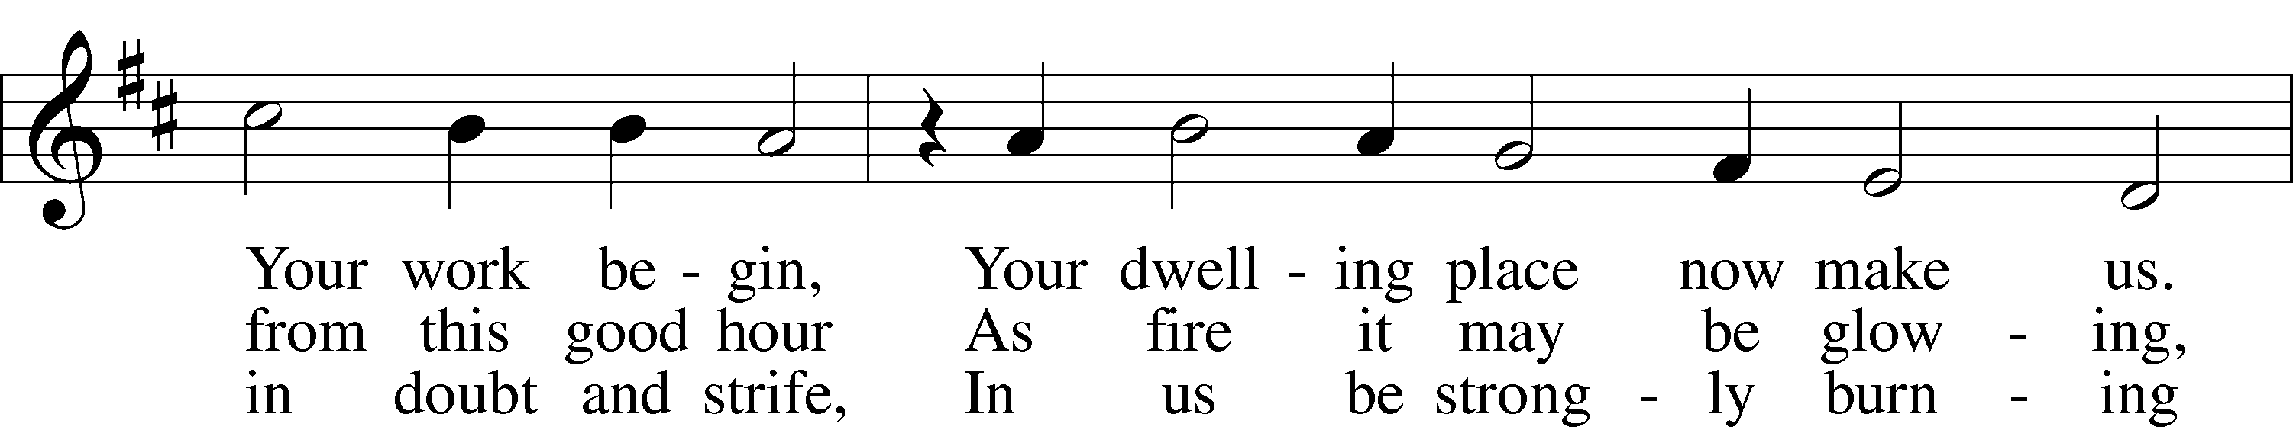
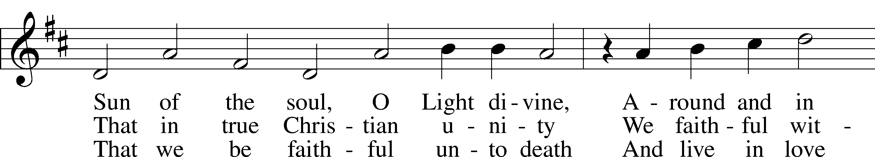
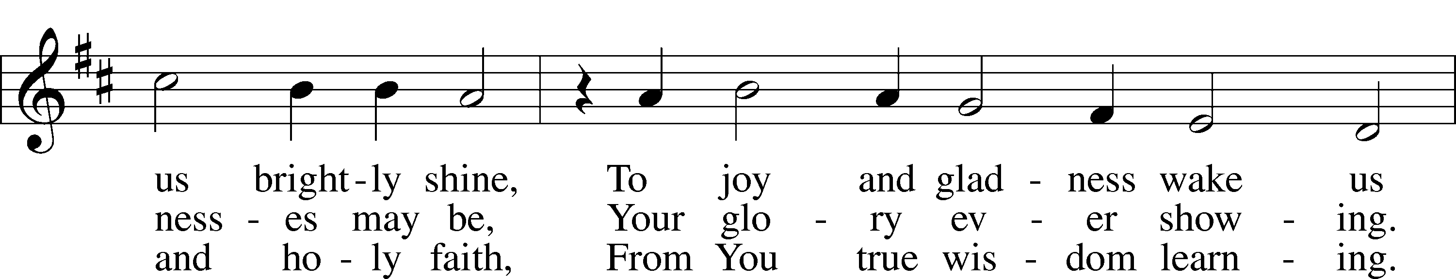
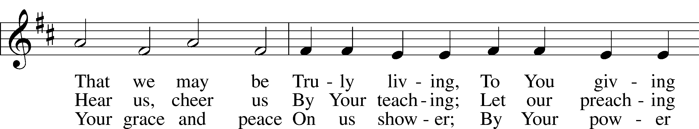
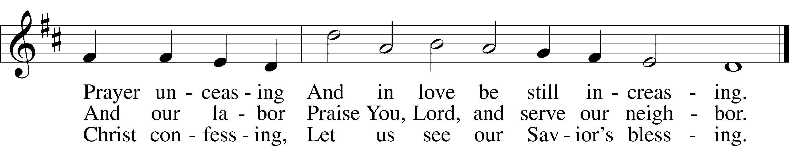

Text: Michael Schirmer, 1606–73, adapt.; (sts. 1, 3): tr. Catherine Winkworth, 1827–78, alt.; (st. 2): tr. The Lutheran Hymnal, 1941, alt.
Tune: Philipp Nicolai, 1556–1608
Text and tune: Public domain

“With Joy We Come Together”

1. With joy we come together,
Our hearts of one accord,
Rejoicing in the blessings
Of serving You, O Lord.
The gifts that You have given
Make us a mighty throng.
With thankfulness we raise up
Our praise to You in song.

2. We celebrate the women,
Who’ve served You through the years,
Sustaining one another
Through vict’ry, trials, and fears.
We follow now their service,
Devoted, Christ, to You.
No matter what Your errand,
We’ll strive to follow through.

3. Through ministries supported,
We’ve seen Your love outpoured.
With mites that You’ve provided,
We’ve learned to trust You, Lord.
Our many hands have served You,
Yet much is left undone.
Your mission must continue
In reaching everyone.

4. Lord, with Your love and guidance,
We’ll serve You faithfully.
Wherever You should lead us,
We’ll follow willingly.
May we be bold in witness
So others see Your grace.
That we may one day worship
Together face to face.

Written by Jean Hansen Kammerer, Stevensville, Montana
Published by Lutheran Women’s Missionary League, 2017
Tune: LSB 527

849 Praise the One Who Breaks the Darkness
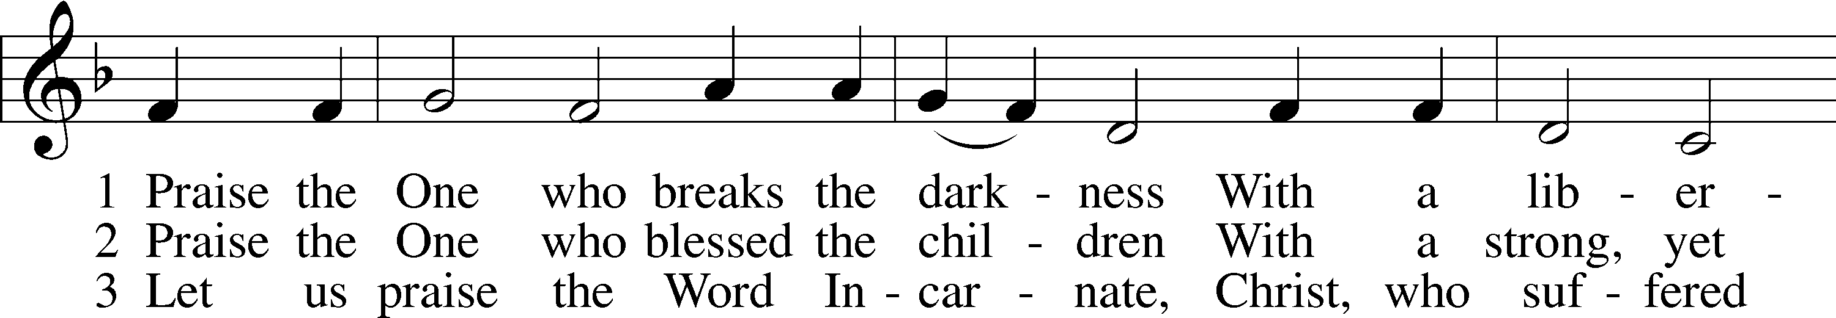
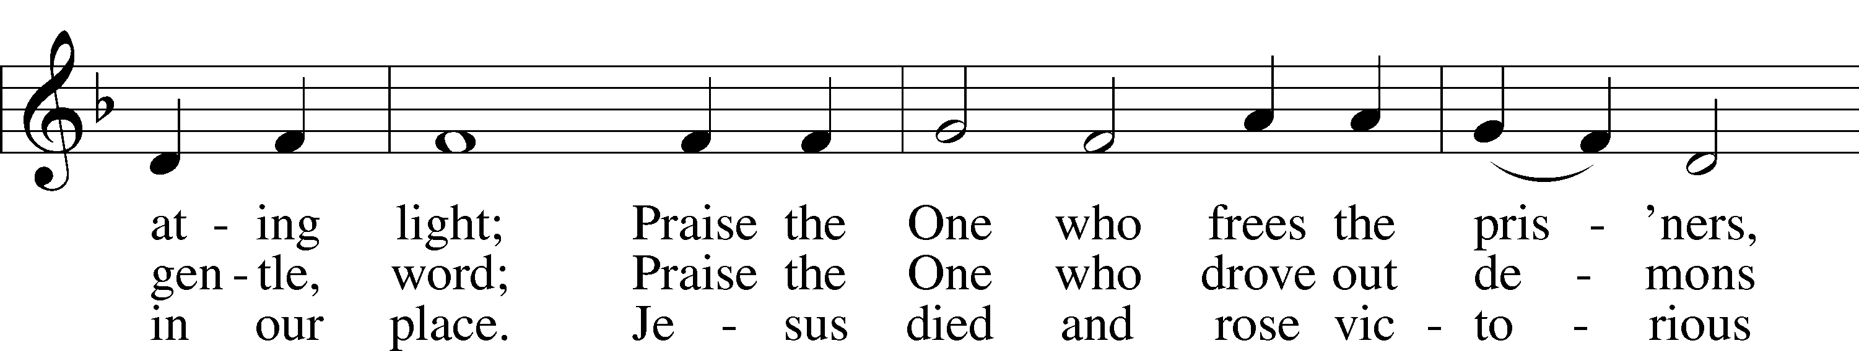
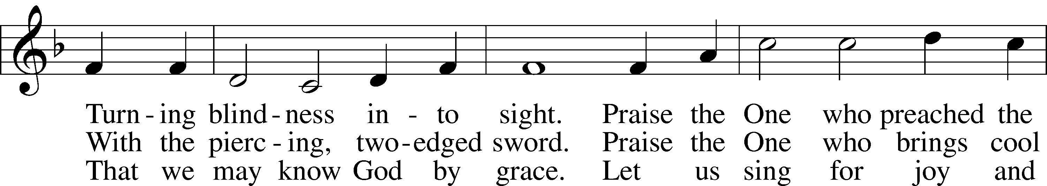
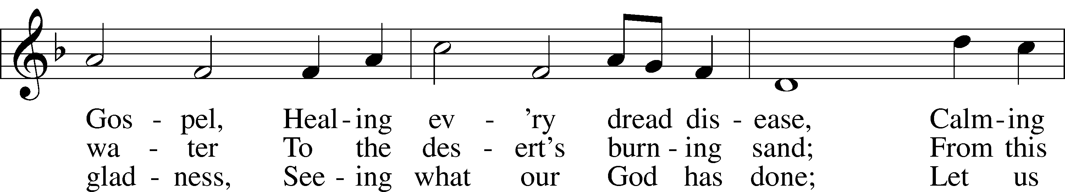
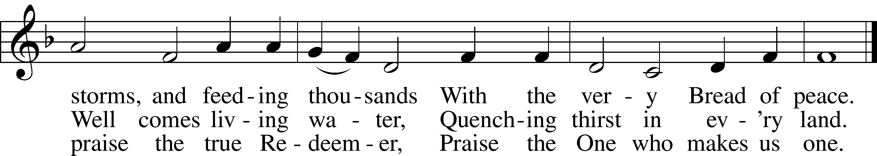

Text: Rusty Edwards, 1955
Tune: The Sacred Harp, 1844, Philadelphia
Text: © 1987 Hope Publishing Co. Used by permission: LSB Hymn License no. 110005275
Tune: Public domain

Stand

Confession and Absolution
The sign of the cross may be made by all in remembrance of their Baptism.

P In the name of the Father and of the Son and of the Holy Spirit.
C Amen.

P If we say we have no sin, we deceive ourselves, and the truth is not in us.
C But if we confess our sins, God, who is faithful and just, will forgive our sins and cleanse us from all unrighteousness.
Silence for reflection on God’s Word and for self-examination.

P Let us then confess our sins to God our Father.
C Most merciful God, we confess that we are by nature sinful and unclean. We have sinned against You in thought, word, and deed, by what we have done and by what we have left undone. We have not loved You with our whole heart; we have not loved our neighbors as ourselves. We justly deserve Your present and eternal punishment. For the sake of Your Son, Jesus Christ, have mercy on us. Forgive us, renew us, and lead us, so that we may delight in Your will and walk in Your ways to the glory of Your holy name. Amen.

P Almighty God in His mercy has given His Son to die for you and for His sake forgives you all your sins. As a called and ordained servant of Christ, and by His authority, I therefore forgive you all your sins in the name of the Father and of the Son and of the Holy Spirit.
C Amen.

Service of the Word

Psalmody Psalm 1

Refrain: The Lord knows the way of the righteous,
but the way of the wicked will perish.
All: The Lord knows the way of the righteous,
but the way of the wicked will perish.
Choir: Blessèd is the man who walks not in the counsel of the wicked,
nor stands in the way of sinners, nor sits in the seat of scoffers;
but his delight is in the law of the Lord,
and on his law he meditates day and night.
He is like a tree planted by streams of water that yields its fruit in its season, and its leaf does not wither.
In all that he does, he prospers.
The wicked are not so,
but are like chaff that the wind drives away.
Therefore the wicked will not stand in the judgment,
nor sinners in the congregation of the righteous.

All: Glory be to the Father and to the Son
and to the Holy Spirit;
as it was in the beginning,
is now, and will be forever. Amen.
Refrain: For the Lord knows the way of the righteous,
but the way of the wicked will perish.

Kyrie LSB 152
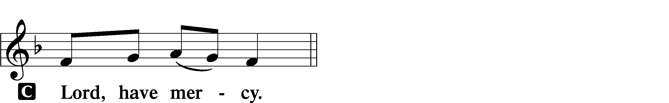

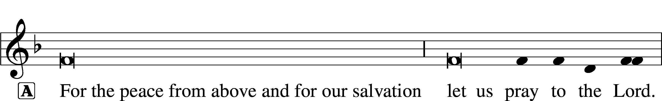

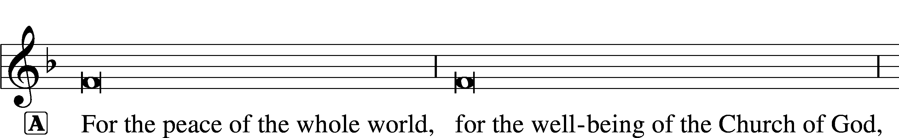

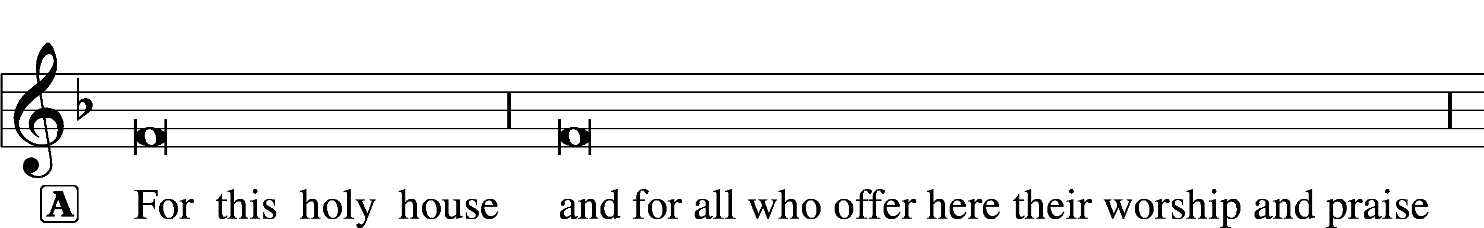

This Is the Feast LSB 155
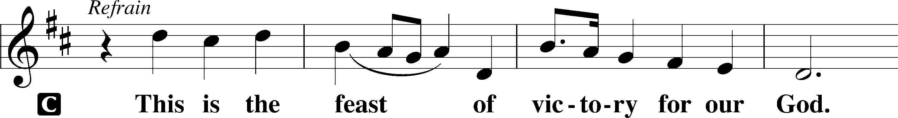
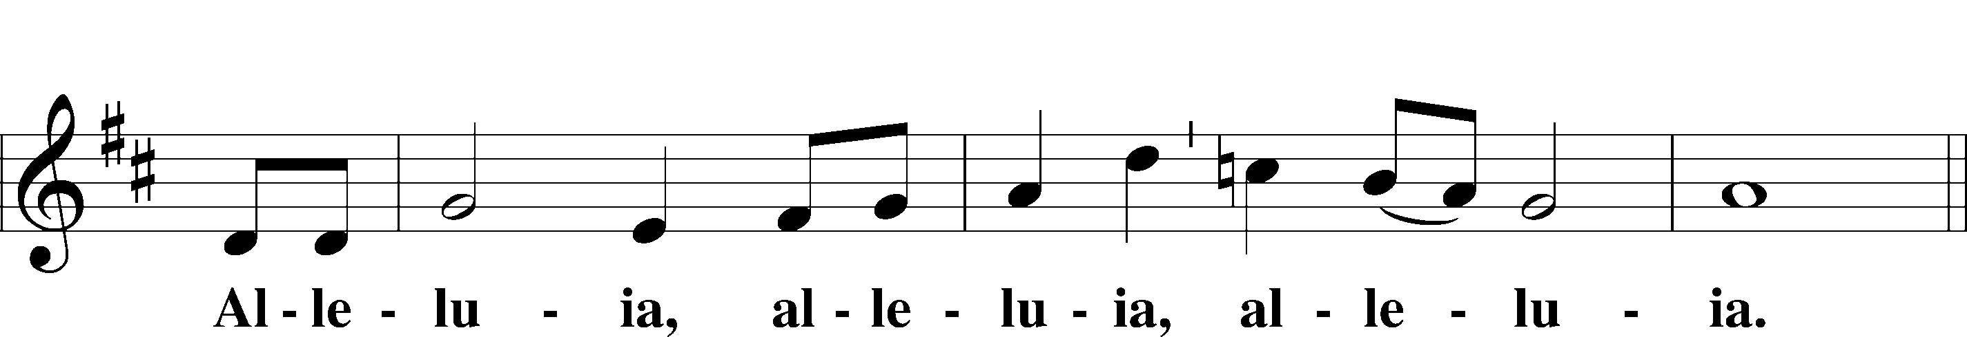
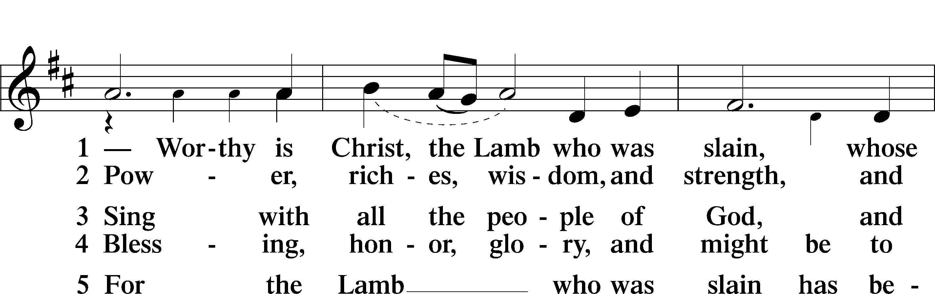
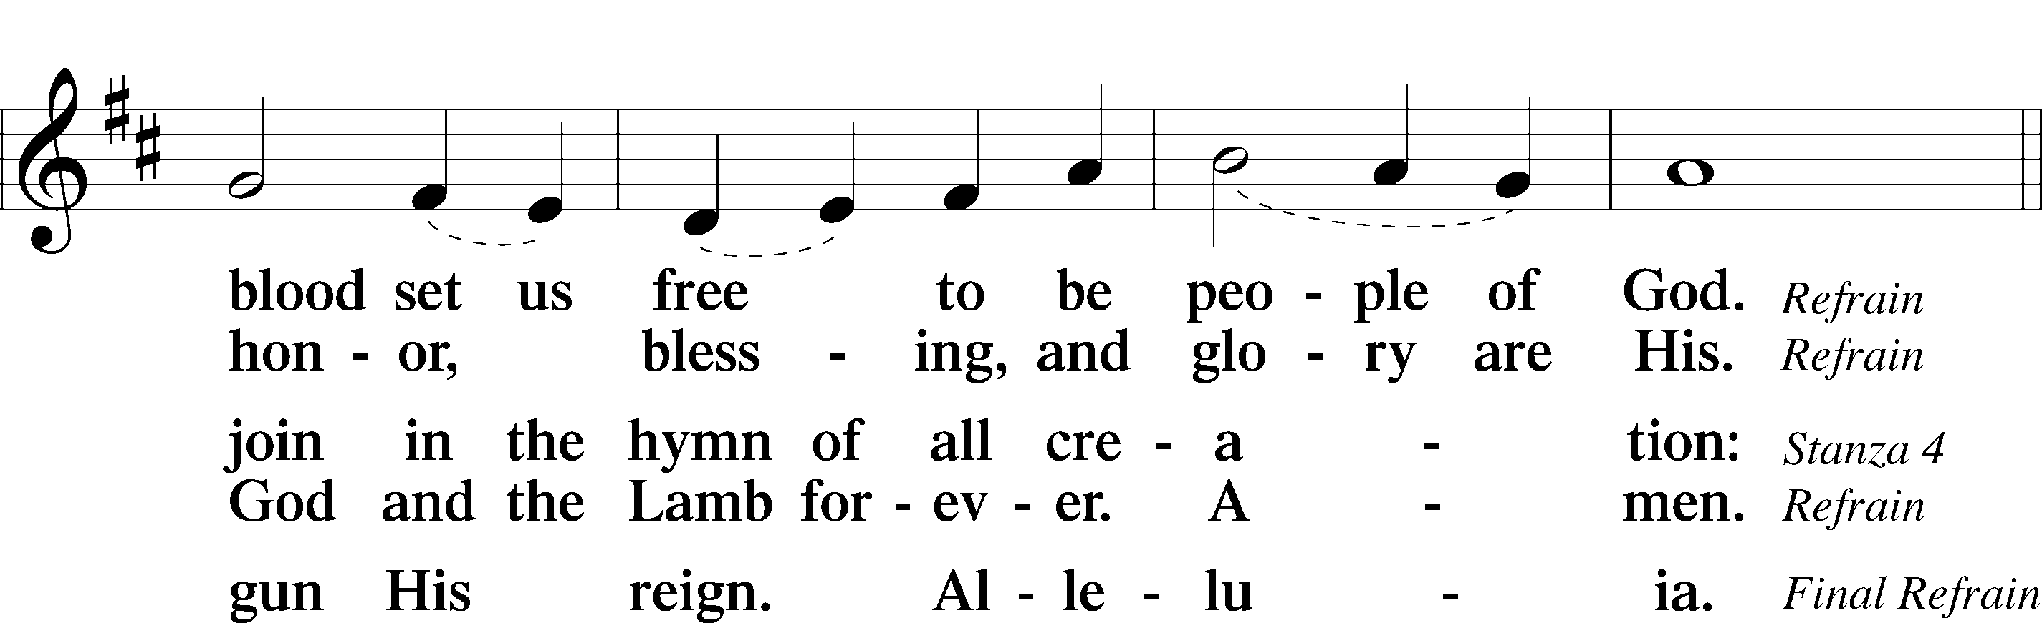

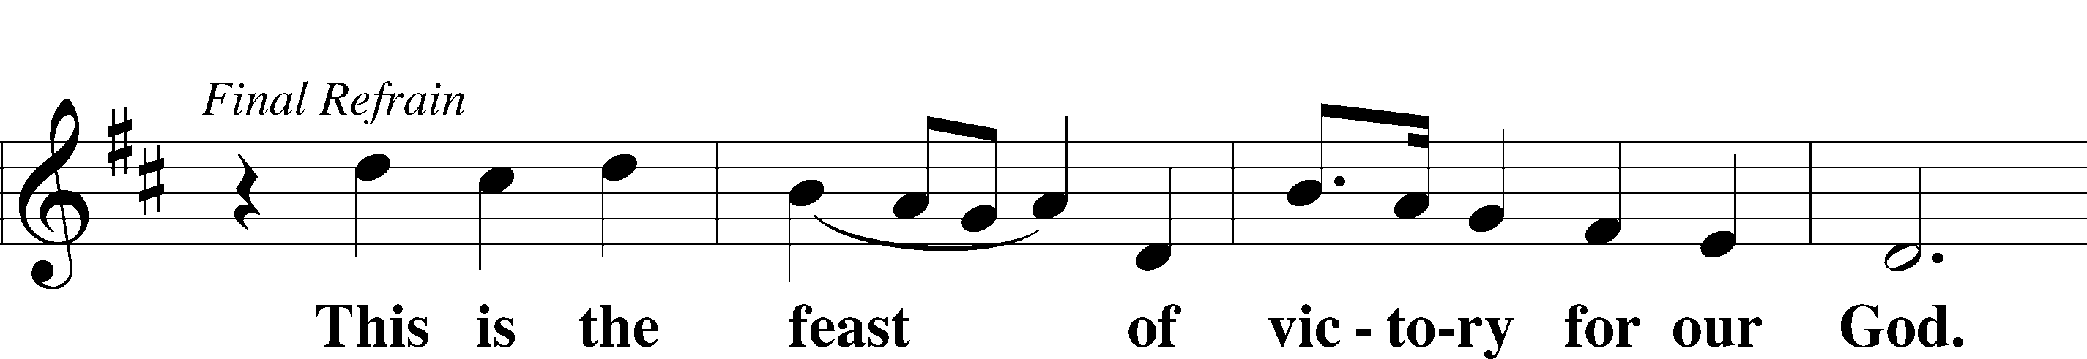
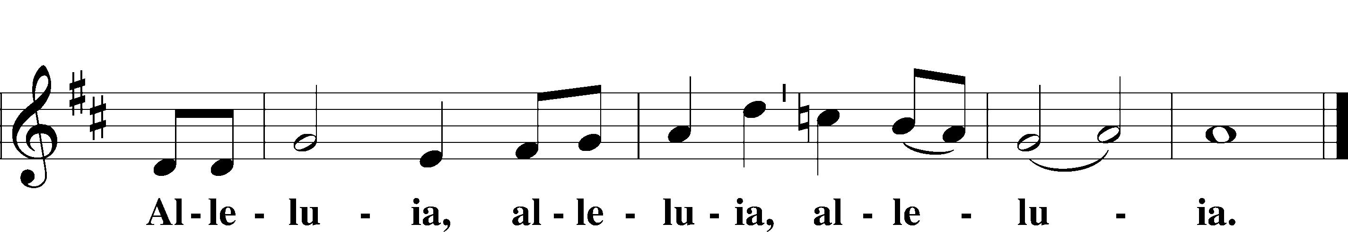

Salutation and Collect of the Day
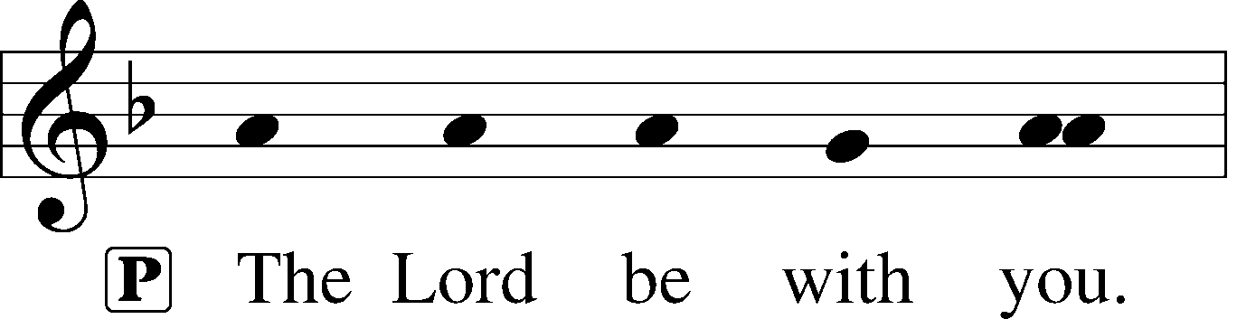
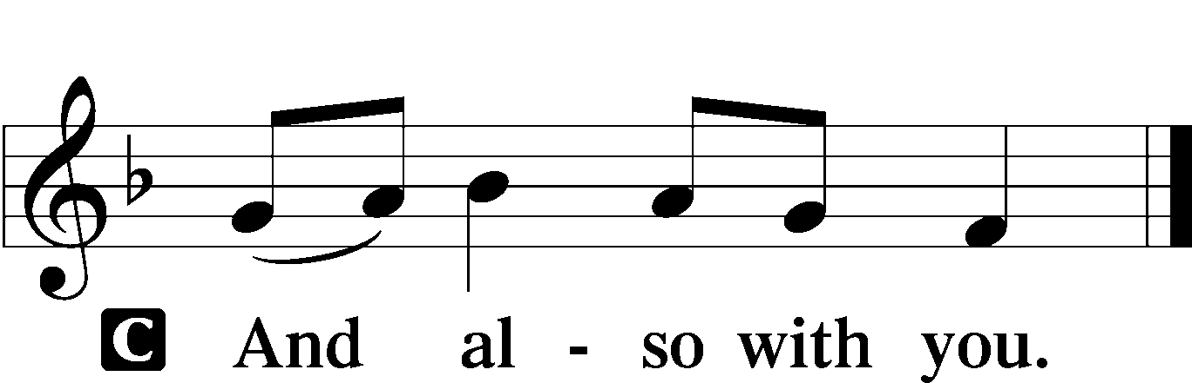

P Let us pray.
Blessed Lord, since You have caused all Holy Scriptures to be written for our learning, grant that we may so hear them, read, mark, learn, and inwardly digest them that we may embrace and ever hold fast the blessed hope of everlasting life; through Jesus Christ, Your Son, our Lord, who lives and reigns with You and the Holy Spirit, one God, now and forever.

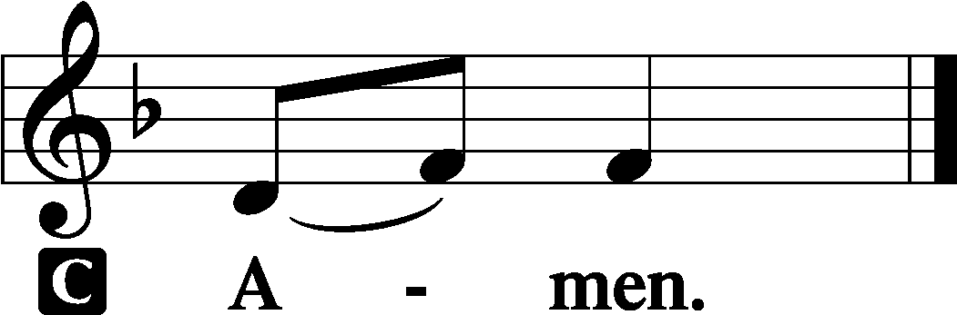

Sit

Old Testament Lesson Jeremiah 17:5–8
5Thus says the Lord:
“Cursed is the man who trusts in man
and makes flesh his strength,
whose heart turns away from the Lord.
6He is like a shrub in the desert,
and shall not see any good come.
He shall dwell in the parched places of the wilderness,
in an uninhabited salt land.
7“Blessed is the man who trusts in the Lord,
whose trust is the Lord.
8He is like a tree planted by water,
that sends out its roots by the stream,
and does not fear when heat comes,
for its leaves remain green,
and is not anxious in the year of drought,
for it does not cease to bear fruit.”

Choral Anthem "Christ The Sure and Steady Anchor"

Epistle Lesson Hebrews 10:11–25

11Every priest stands daily at his service, offering repeatedly the same sacrifices, which can never take away sins. 12But when Christ had offered for all time a single sacrifice for sins, he sat down at the right hand of God, 13waiting from that time until his enemies should be made a footstool for his feet. 14For by a single offering he has perfected for all time those who are being sanctified.
15And the Holy Spirit also bears witness to us; for after saying,
16“This is the covenant that I will make with them
after those days, declares the Lord:
I will put my laws on their hearts,
and write them on their minds,”
17then he adds,
“I will remember their sins and their lawless deeds no more.”
18Where there is forgiveness of these, there is no longer any offering for sin.
19Therefore, brothers, since we have confidence to enter the holy places

by the blood of Jesus, 20by the new and living way that he opened for us
through the curtain, that is, through his flesh, 21and since we have a great priest over the house of God, 22let us draw near with a true heart in full assurance of faith, with our hearts sprinkled clean from an evil conscience and our bodies washed with pure water. 23Let us hold fast the confession of our hope without wavering, for he who promised is faithful. 24And let us consider how to stir up one another to love and good works, 25not neglecting to meet together, as is the habit of some, but encouraging one another, and all the more as you see the Day drawing near.

Stand

Alleluia and Verse LSB 156
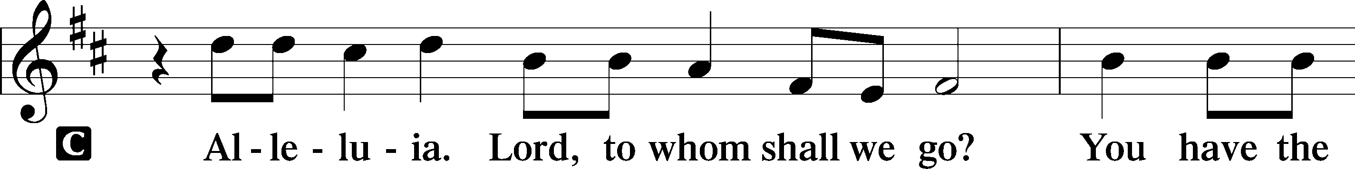
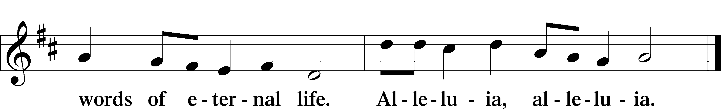

Holy Gospel John 13:31b–35
P The Holy Gospel according to St. John, the thirteenth chapter.

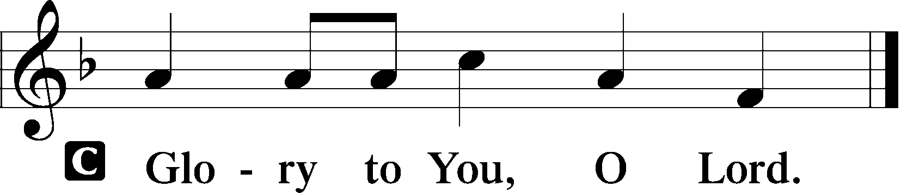

“Now is the Son of Man glorified, and God is glorified in him. 32If God is glorified in him, God will also glorify him in himself, and glorify him at once. 33Little children, yet a little while I am with you. You will seek me, and just as I said to the Jews, so now I also say to you, ‘Where I am going you cannot come.’ 34A new commandment I give to you, that you love one another: just as I have loved you, you also are to love one another. 35By this all people will know that you are my disciples, if you have love for one another.”

P This is the Gospel of the Lord.

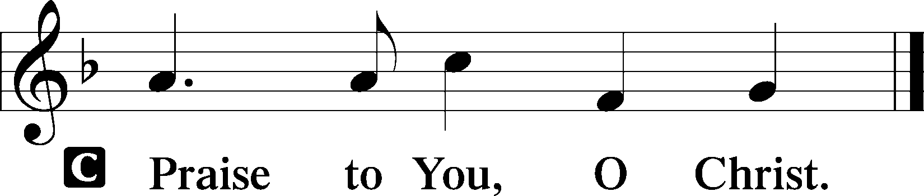

Sit

525 Crown Him with Many Crowns
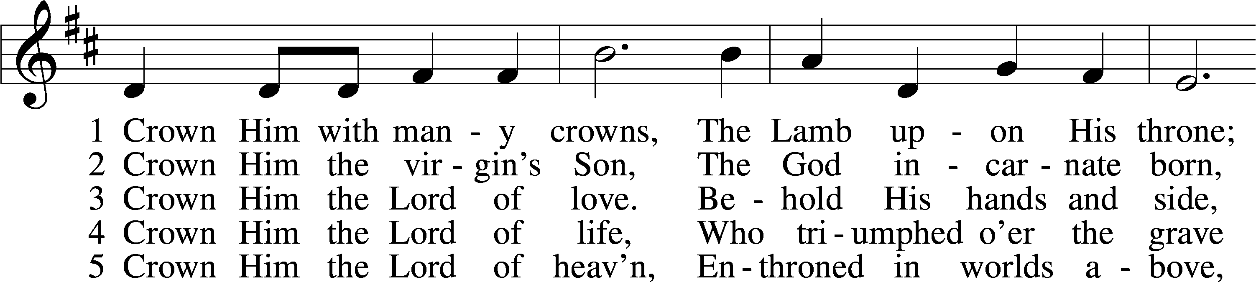
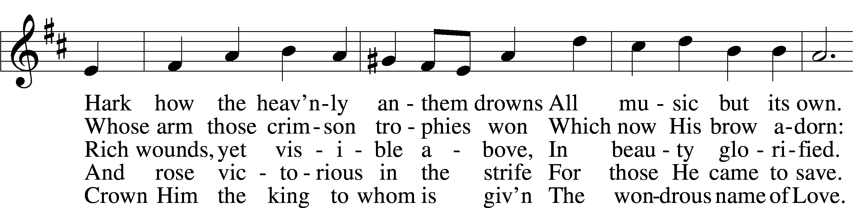
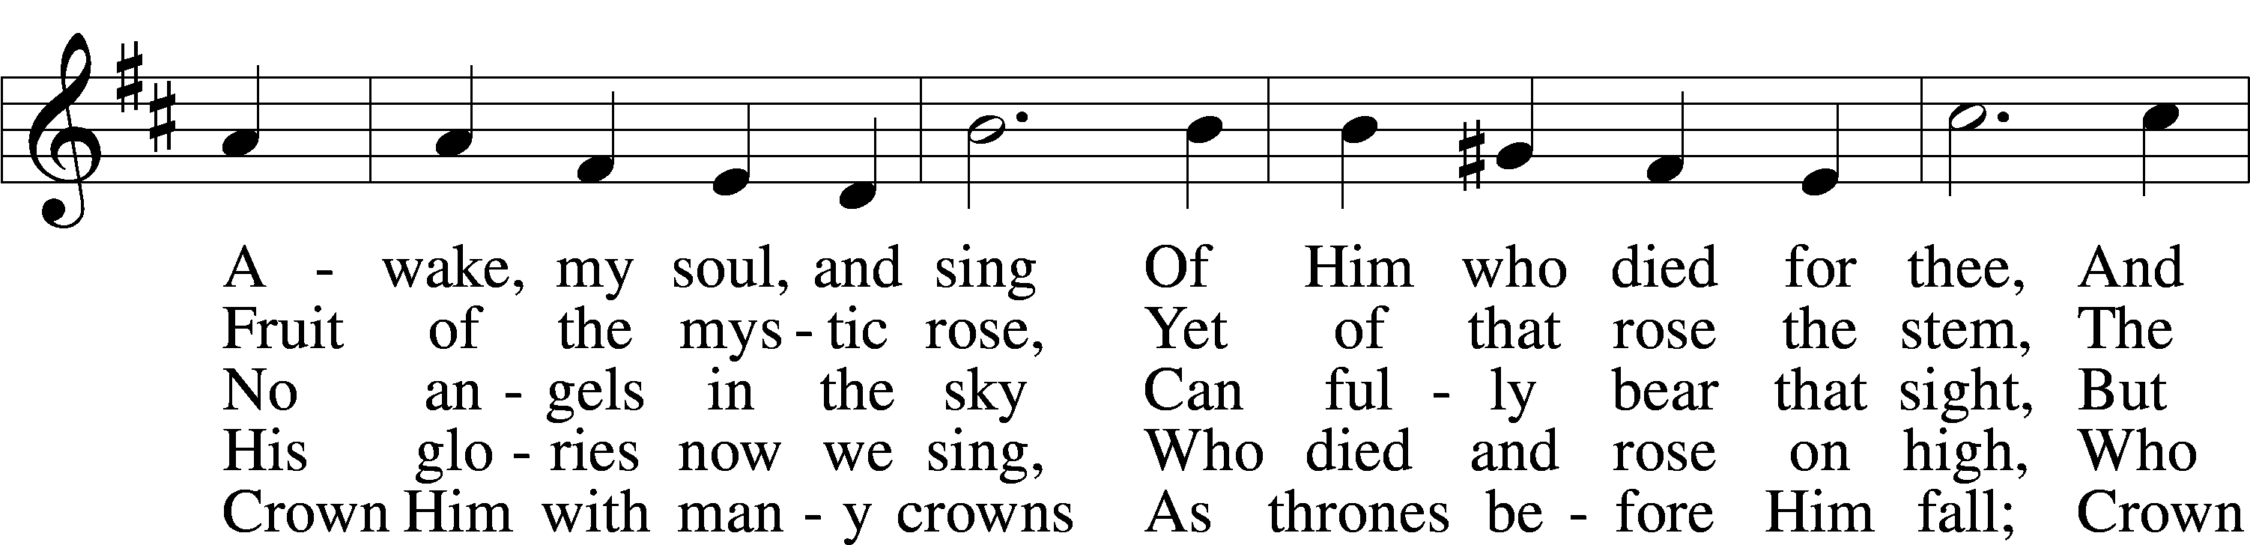
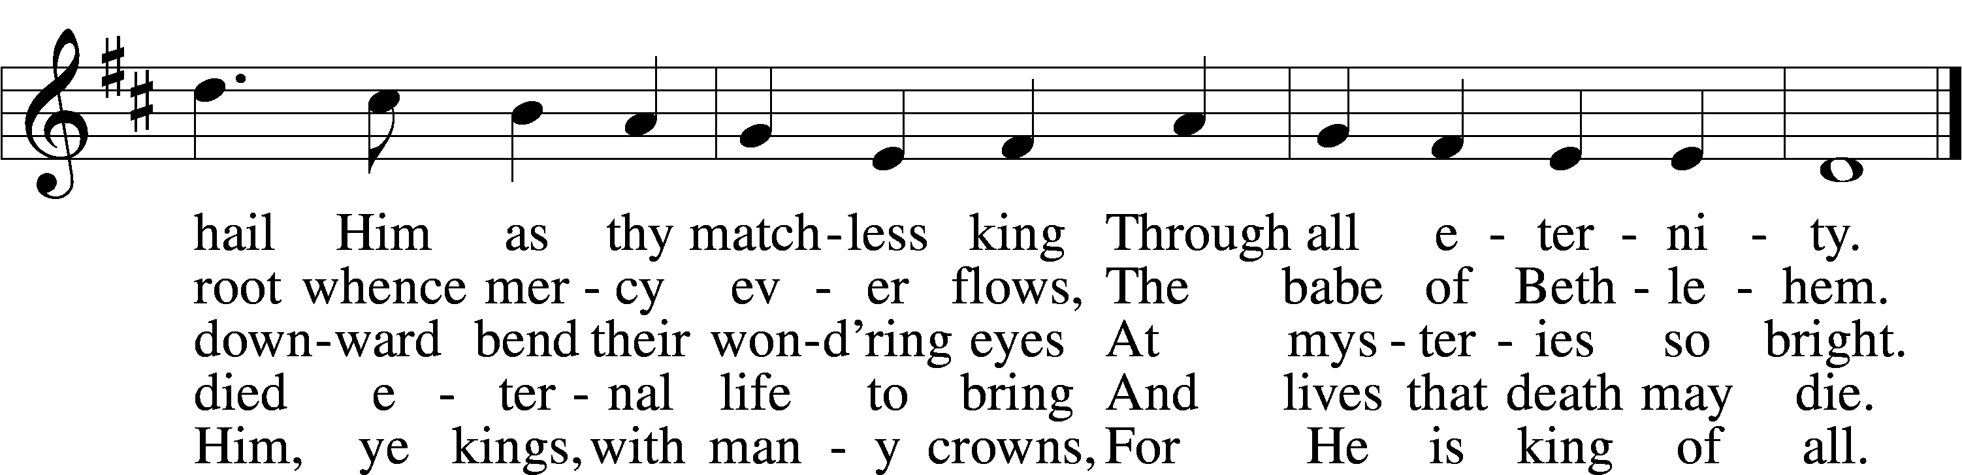

Text (sts. 1–3, 5): Matthew Bridges, 1800–94, alt.; (st. 4): Godfrey Thring, 1823–1903
Tune: George J. Elvey, 1816–93
Text and tune: Public domain

Sermon Title: “Hold Fast and Stir Up — Christ is Our Anchor!”
Text: Let us hold fast the confession of our hope without wavering, for he who
promised is faithful. And let us consider how to stir up one another to
love and good works, (Hebrews 10:23–24).

Stand

Nicene Creed

C I believe in one God,
the Father Almighty,
maker of heaven and earth
and of all things visible and invisible.

And in one Lord Jesus Christ,
the only-begotten Son of God,
begotten of His Father before all worlds,
God of God, Light of Light,
very God of very God,
begotten, not made,
being of one substance with the Father,
by whom all things were made;
who for us men and for our salvation came down from heaven
and was incarnate by the Holy Spirit of the virgin Mary
and was made man;
and was crucified also for us under Pontius Pilate.
He suffered and was buried.
And the third day He rose again according to the Scriptures
and ascended into heaven
and sits at the right hand of the Father.
And He will come again with glory to judge both the living and the dead,
whose kingdom will have no end.

And I believe in the Holy Spirit,
the Lord and giver of life,
who proceeds from the Father and the Son,
who with the Father and the Son together is worshiped and glorified,
who spoke by the prophets.
And I believe in one holy Christian and apostolic Church,
I acknowledge one Baptism for the remission of sins,
and I look for the resurrection of the dead
and the life of the world to come. Amen.

Prayer of the Church

P Friends in Christ, lift up your hearts to God and pray with me.

P Almighty God, give to your church a boldness of faith which is not afraid to go where You lead us. Lord, in Your mercy,
C hear our prayer.

P We thank You for the mission and ministry of the Lutheran Women’s Missionary League, supporting Your work across the world. By Your Spirit, strengthen and encourage all Christian women as they fulfill their various callings in service to You. Sustain our generosity as we support mission outreach through our LWML Mite Boxes. Lord, by Your power, multiply our gifts for Your kingdom’s increase. Lord, in Your mercy,
C hear our prayer.

P We thank You for the opportunities You have given to us in these days to be about Your business of not only sharing items and time that make life more enjoyable for many whose lives we touch, but also for giving us the opportunities as we serve in these ways and share these things to share the Good News of our Lord and Savior Jesus Christ and His gift of sins forgiven and life eternal through faith in Him alone. We thank You for letting us be involved by collecting items for the Upbring Children Centers, Bokenkamp Center in Corpus Christi, and New Life in Canyon Lake; for various Rainbow Rooms; for New Life Refuge Ministries; and for the Pregnancy Center of the Coastal Bend. We thank You also for the opportunity to work alongside your people at the Brookdale Trinity Towers Assisted Living Facility; the Alameda Oaks Nursing Center; the Ronald McDonald House; and the Hi Again Resale Shop; as well as to work in this hotel with fellow LWMLers as we tack lap quilts for Fisher Houses in San Antonio; tie fleece blankets for New Life Refuge Ministries, Corpus Christi; complete breast pillows for cancer patients at Christus Spohn Cancer Center in Corpus Christi; mark Bibles for the Coastal Bend Detention Center in Robstown; and write notes of thanks and encouragement to military personnel, missionaries, and first responders. Use us and these gifts to show Your love to those whose lives they will impact. Lord, in Your mercy,
C hear our prayer.

P Bring healing, Lord, to those who are sick, as well as comfort and hope to the grieving, including those we now name silently before You. Lord, in Your mercy,
C hear our prayer.
P For all who lead in the world and in our nation, including President Joseph Biden, Governor Greg Abbott, as well as all who make our laws; and for those who lead in Your church, including President Matthew Harrison, and our Texas District President, Pastor Mike Newman; empower each and every one of them to lead with humility, wisdom, justice, and peace. Protect all who serve us in harm’s way, including those near and dear to us who we name silently before You. Lord, in Your mercy,
C hear our prayer.

P Bless our time of fellowship, and then our time of rest this evening, refreshing us to serve You on the morrow as we get down to the business of the LWML; choosing mission grants, electing officers to serve us and You, listening to exciting tales from our speakers, and transacting the business that needs to be taken care of as we strive with Your blessing to continue to make the LWML the premier women’s mission and ministry group in the world. Lord, in Your mercy,
C hear our prayer.

P Lord of life, use us, Your people, to provide for the poor and the hungry across the world. Through Your church, preserve and defend the unborn and all victims of hate and injustice. Renew our faith as we serve boldly in Your kingdom; through Jesus Christ, our Lord.
C Amen.

Following the prayers, the people may greet one another in the name of the Lord, saying, “Peace be with you,” as a sign of reconciliation and of the unity of the Spirit in the bond of peace (Matt. 5:22–24; Eph. 4:1–3).

Sit

Offering
(The offerings received at this worship service will be used as the first fruits given to carry out the 2024–2026 Mission Goal of the LWML Texas District.)

Choral Anthem "Christ Jesus Is Our Anchor"
Refrain:
Christ Jesus is our anchor;
His promise will prevail.
Whatever storm or danger,
This hope will never fail.
1. In death, Christ went before us;
Forgiveness is secured.
He rose to life victorious;
Salvation is assured.
Christ Jesus is our anchor;
His promise will prevail.
Whatever storm or danger,
This hope will never fail.

2. The sin that clings so closely
Would set our lives adrift;
Christ rescues us from peril
Through His Baptismal gift.
Christ Jesus is our anchor;
His promise will prevail.
Whatever storm or danger,
This hope will never fail.

3. The devil would deceive us
To wreck our faith with lies;
To navigate our journey,
God’s Word will make us wise.
Christ Jesus is our anchor;
His promise will prevail.
Whatever storm or danger,
This hope will never fail.

4. The fear of death that threatens
Would sink us in despair;
Christ buoys us with courage:
His meal of life we share.
Christ Jesus is our anchor;
His promise will prevail.
Whatever storm or danger,
This hope will never fail.

5. Our enemies would drown us,
So Christ will never cease
To breathe His life into us
Through His absolving peace.
Christ Jesus is our anchor;
His promise will prevail.
Whatever storm or danger,
This hope will never fail.

6. The Church sails in the deluge;
Christ charts our passage through.
Lord, bring Your Ark to harbor
Forevermore with You.
Christ Jesus is our anchor;
His promise will prevail.
Whatever storm or danger,
This hope will never fail.

“Christ Jesus is Our Anchor”
A Hymn for the 2020 LWML Texas District Convention
Based on Hebrews 6:19-20; Hebrews 12:1-3; John 20:19-23
Text: © Pastor Timothy Appel, 2019
Tune: © Allison Ulmer, 2020

Stand

Offertory LSB 159
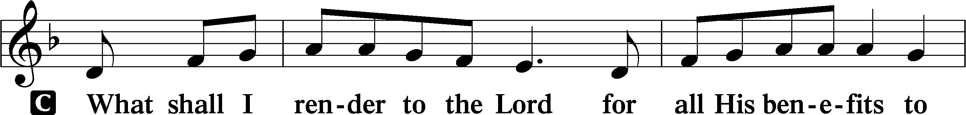
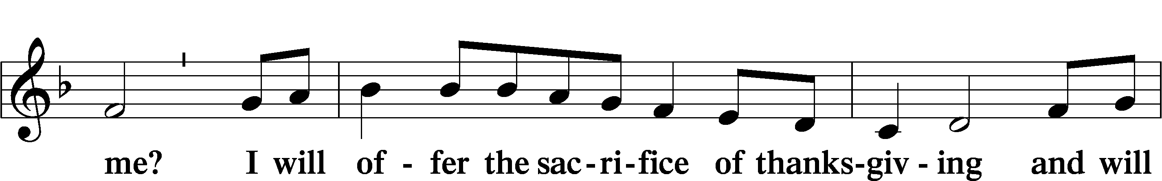
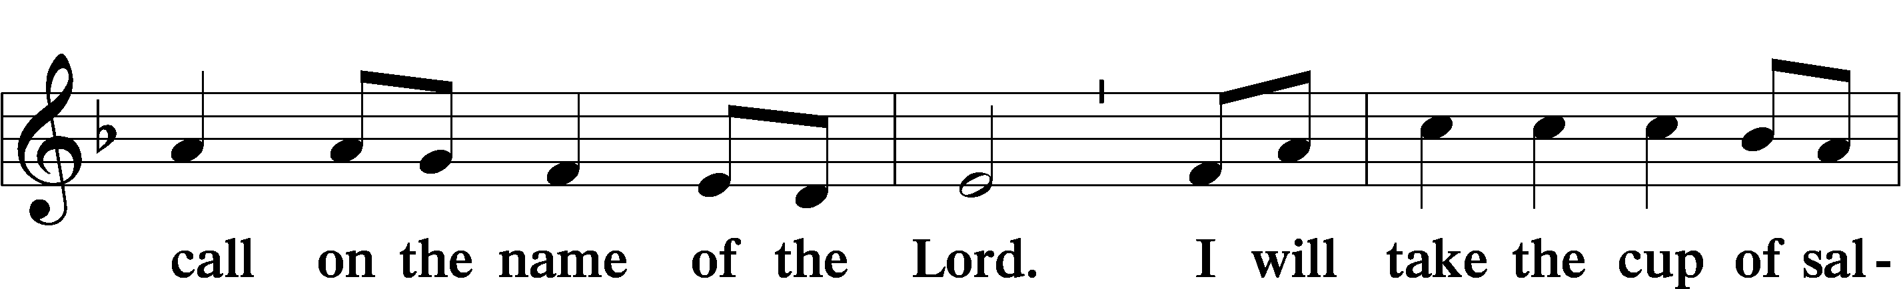
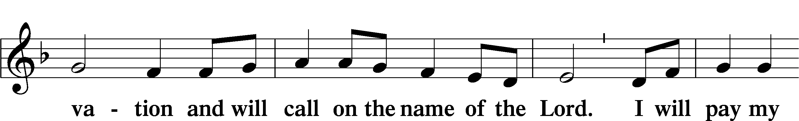
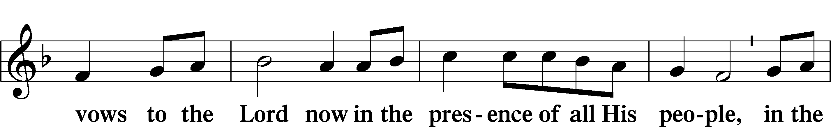
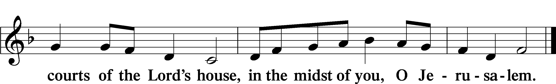

Service of the Sacrament

Preface LSB 160

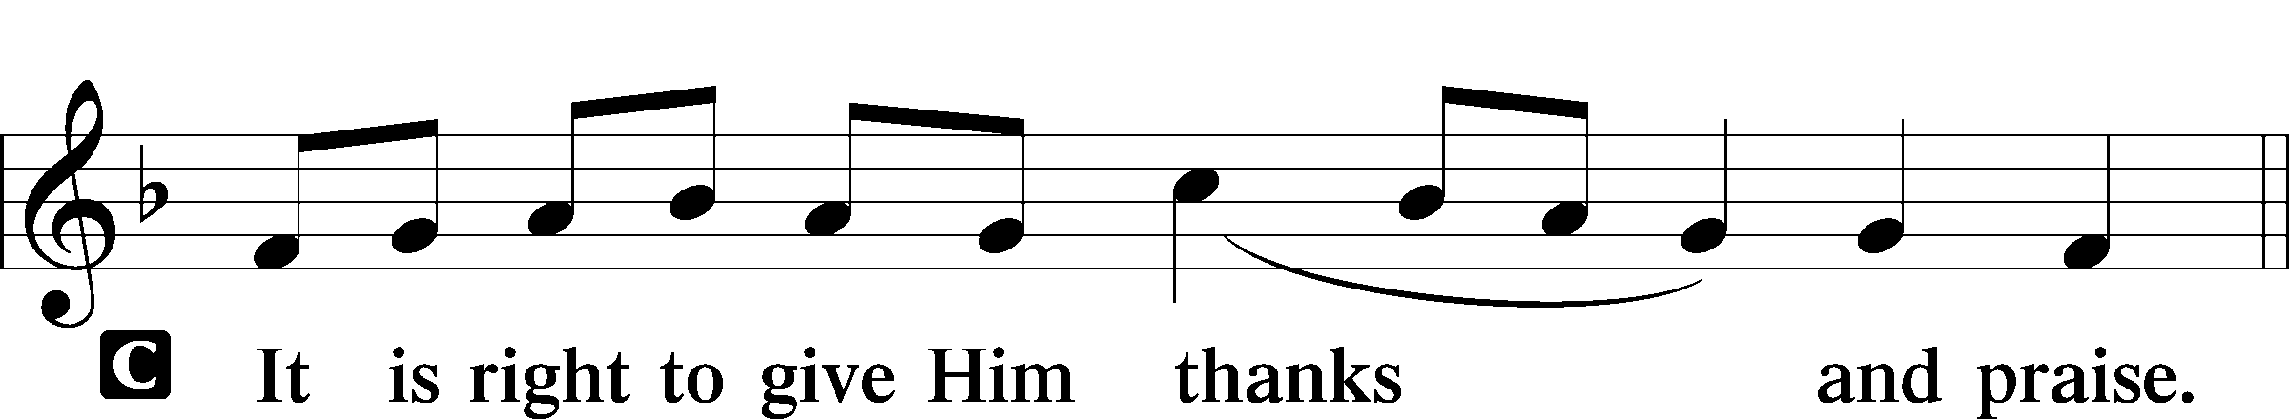

P It is truly good, right, and salutary that we should at all times and in all places give thanks to You, holy Lord, almighty Father, everlasting God, through Jesus Christ, our Lord, who, out of love for His fallen creation, humbled Himself by taking on the form of a servant, becoming obedient unto death, even death upon a cross. Risen from the dead, He has freed us from eternal death and given us life everlasting. Therefore with angels and archangels and with all the company of heaven we laud and magnify Your glorious name, evermore praising You and saying:

Sanctus LSB 161
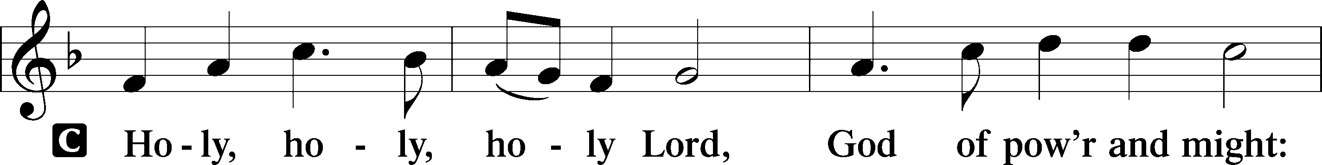
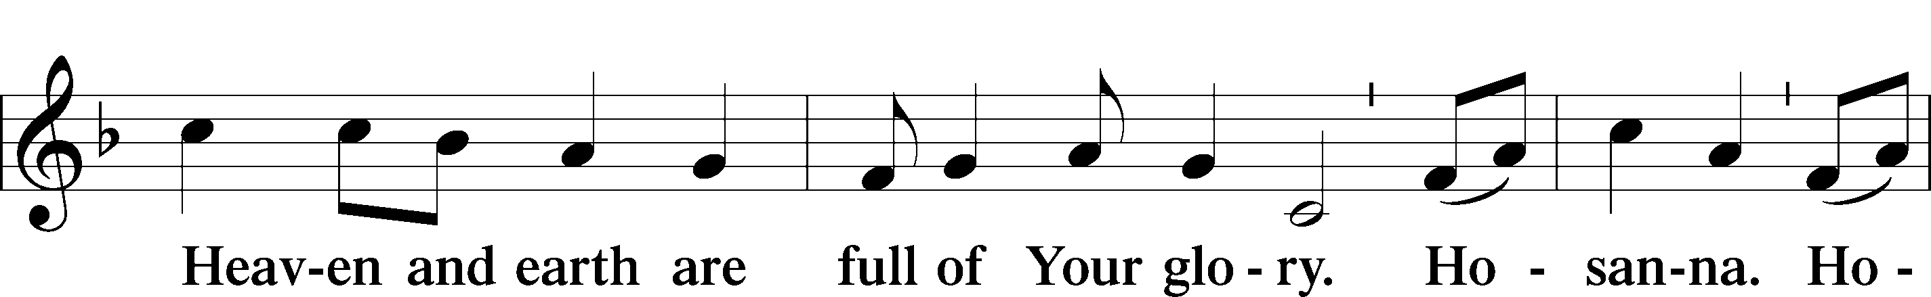
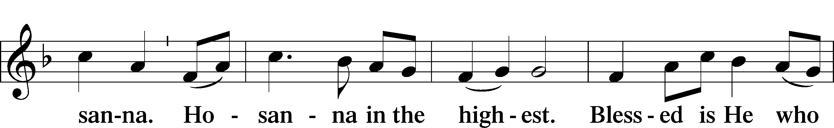

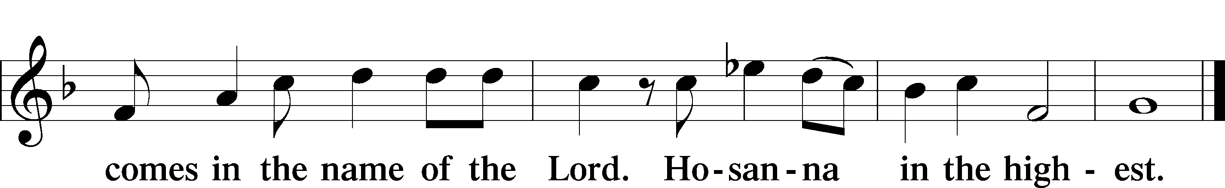

Prayer of Thanksgiving LSB 161

P Blessed are You, Lord of heaven and earth, for You have had mercy on those whom You created and sent Your only-begotten Son into our flesh to bear our sin and be our Savior. With repentant joy we receive the salvation accomplished for us by the all-availing sacrifice of His body and His blood on the cross.

Gathered in the name and the remembrance of Jesus, we beg You, O Lord, to forgive, renew, and strengthen us with Your Word and Spirit. Grant us faithfully to eat His body and drink His blood as He bids us do in His own testament. Gather us together, we pray, from the ends of the earth to celebrate with all the faithful the marriage feast of the Lamb in His kingdom, which has no end. Graciously receive our prayers; deliver and preserve us. To You alone, O Father, be all glory, honor, and worship, with the Son and the Holy Spirit, one God, now and forever.
C Amen.

The Words of Our Lord

P Our Lord Jesus Christ, on the night when He was betrayed, took bread, and when He had given thanks, He broke it and gave it to the disciples and said: “Take, eat; this is My body, which is given for you. This do in remembrance of Me.”

In the same way also He took the cup after supper, and when He had given thanks, He gave it to them, saying: “Drink of it, all of you; this cup is the new testament in My blood, which is shed for you for the forgiveness of sins. This do, as often as you drink it, in remembrance of Me.”

P As often as we eat this bread and drink this cup, we proclaim the Lord’s death until He comes.
C Amen. Come, Lord Jesus.

P O Lord Jesus Christ, only Son of the Father, in giving us Your body and blood to eat and to drink, You lead us to remember and confess Your holy cross and passion, Your blessed death, Your rest in the tomb, Your resurrection from the dead, Your ascension into heaven, and Your coming for the final judgment. So remember us in Your kingdom and teach us to pray:

Lord’s Prayer

C Our Father who art in heaven,
hallowed be Thy name,
Thy kingdom come,
Thy will be done on earth
as it is in heaven;
give us this day our daily bread;
and forgive us our trespasses
as we forgive those
who trespass against us;
and lead us not into temptation,
but deliver us from evil.
For Thine is the kingdom
and the power and the glory
forever and ever. Amen.

Pax Domini LSB 163
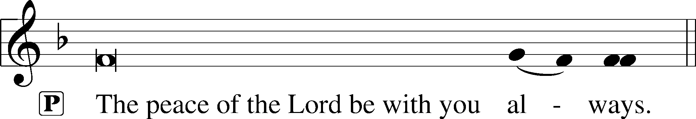

Agnus Dei LSB 163
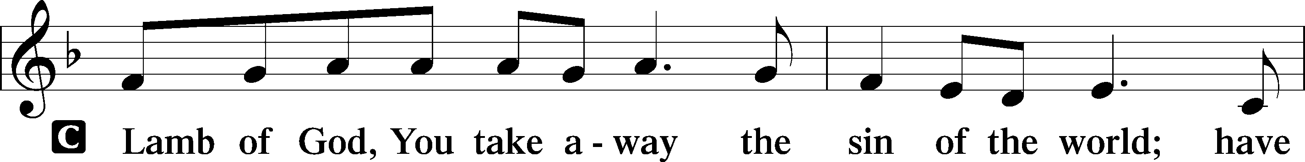
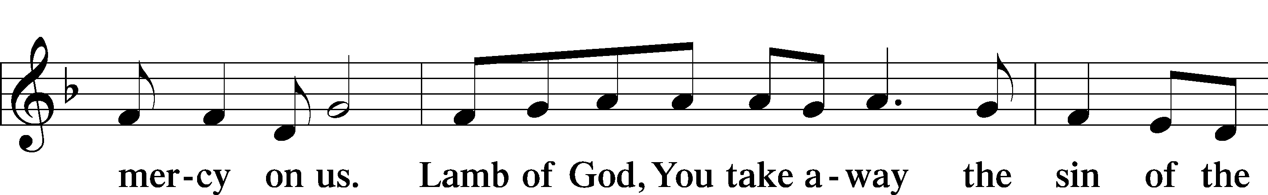
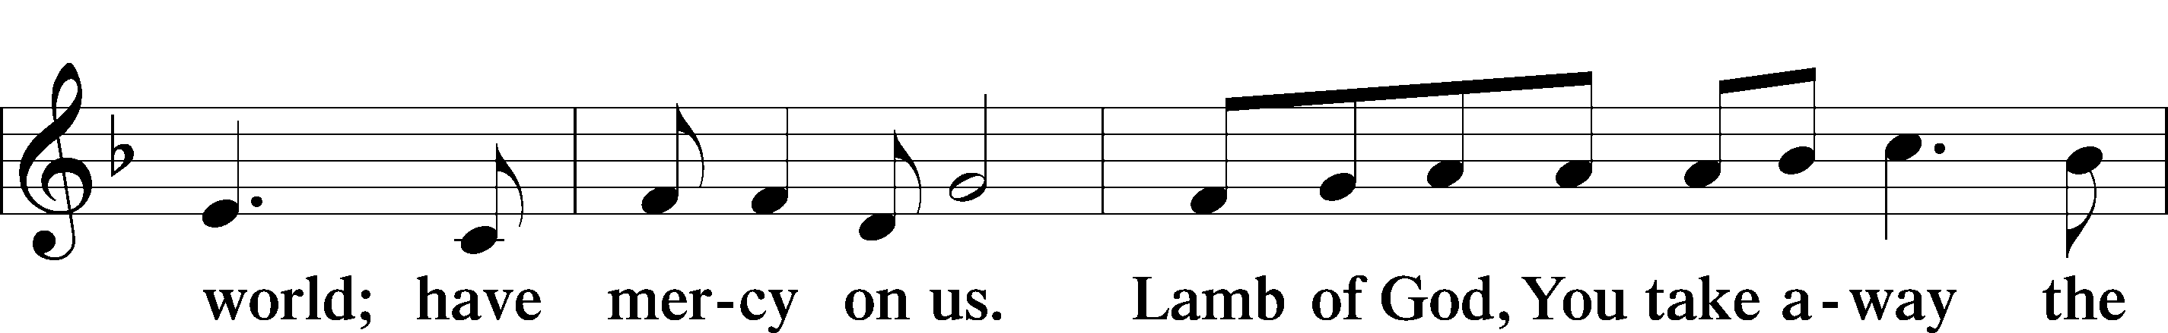
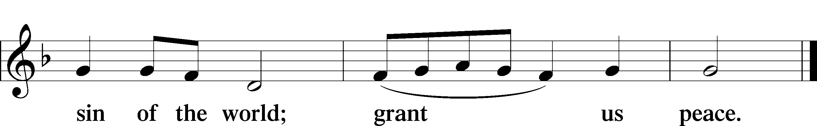

Sit

594 God’s Own Child, I Gladly Say It
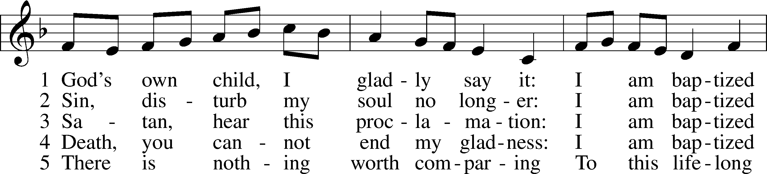
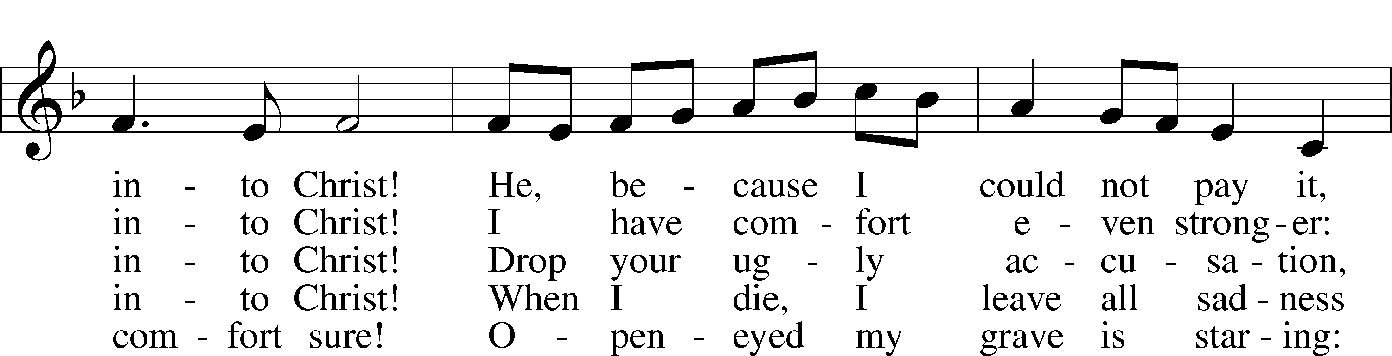
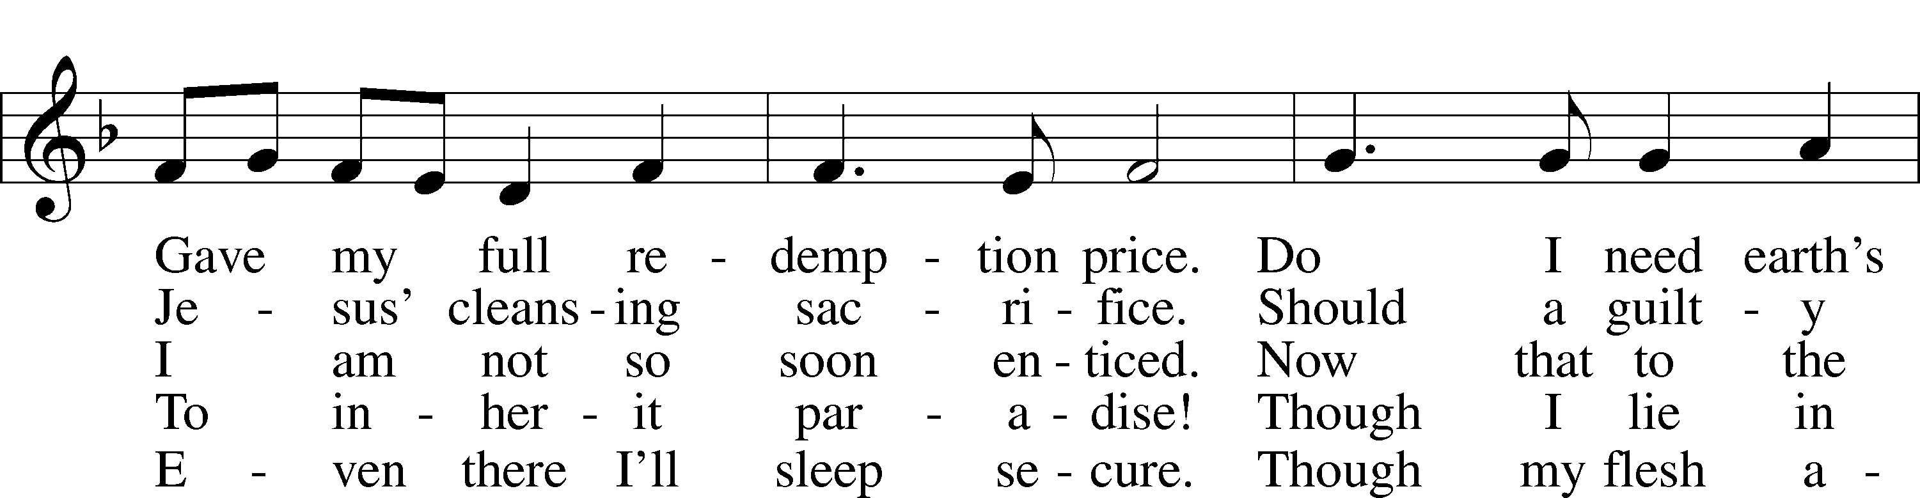
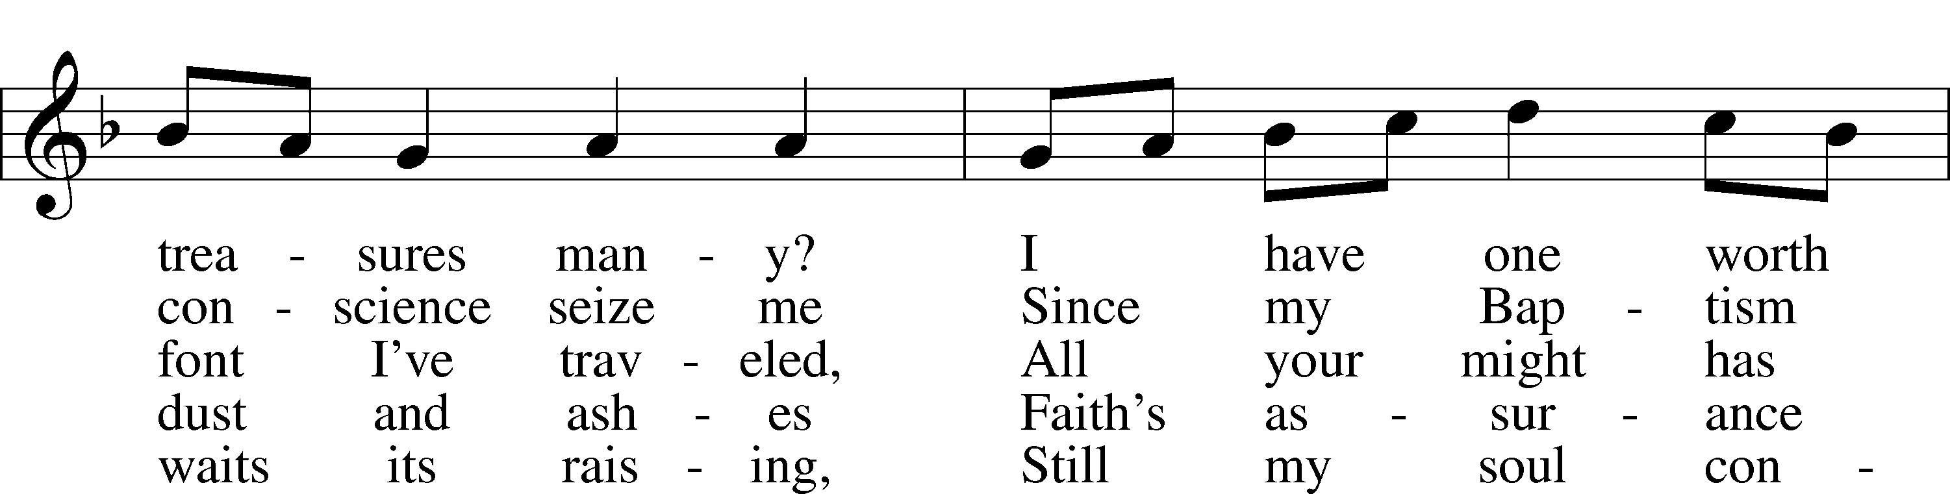
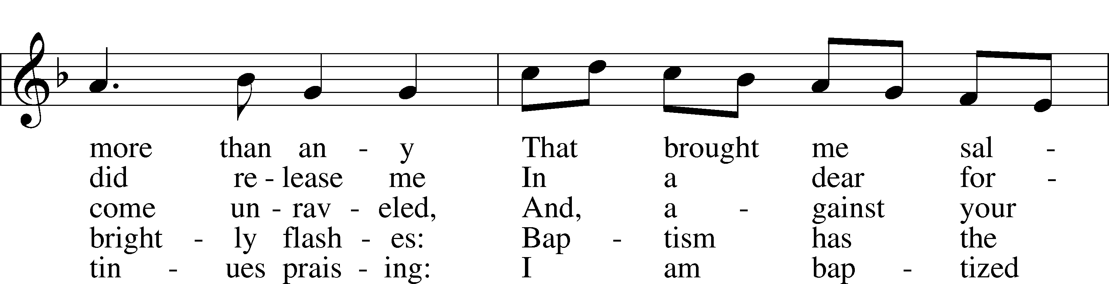

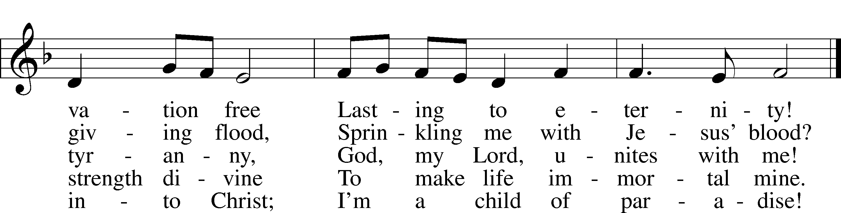

Text: Erdmann Neumeister, 1671–1756; tr. Robert E. Voelker, 1957
Tune: Johann Caspar Bachofen, 1695–1755, alt.
Text: © 1991 Robert E. Voelker. Used by permission: LSB Hymn License no. 110005275
Tune: Public domain

618 I Come, O Savior, to Thy Table
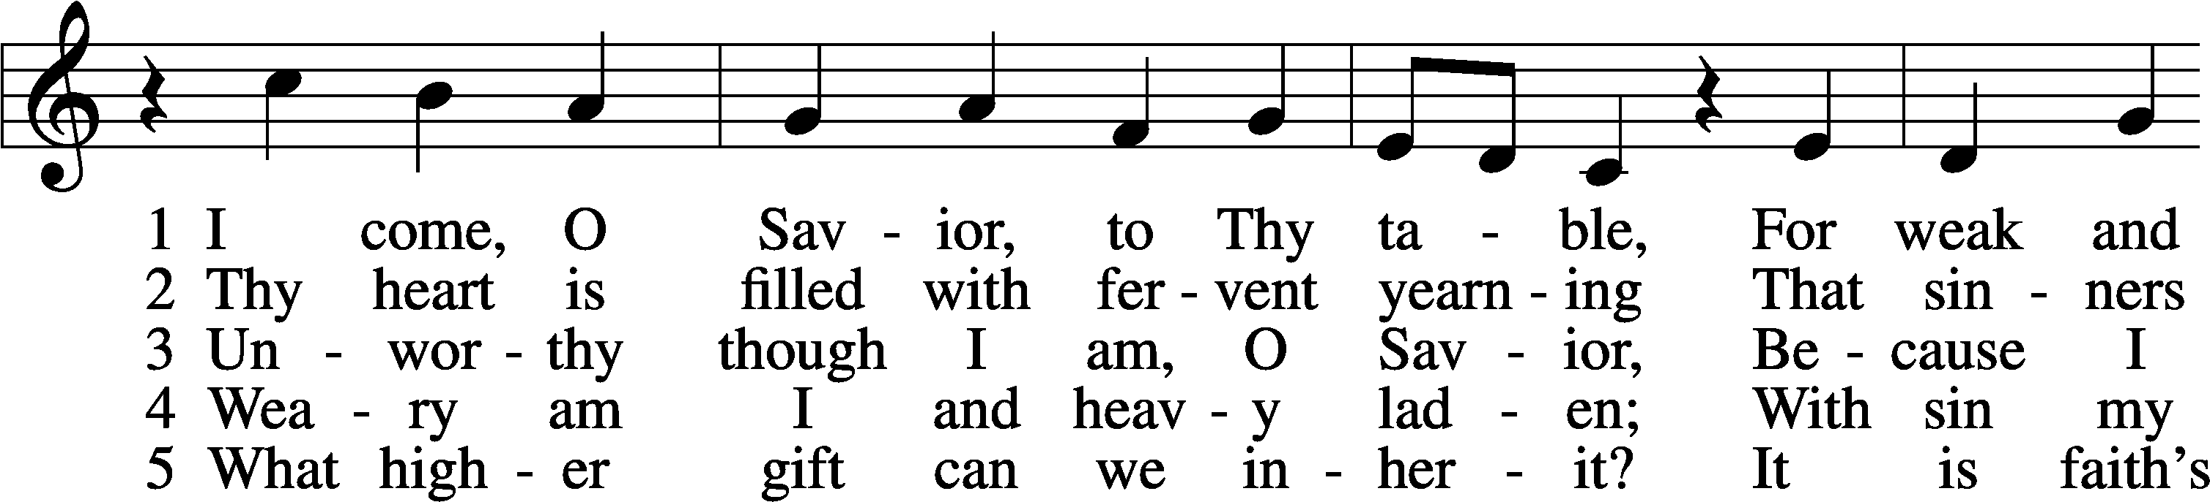
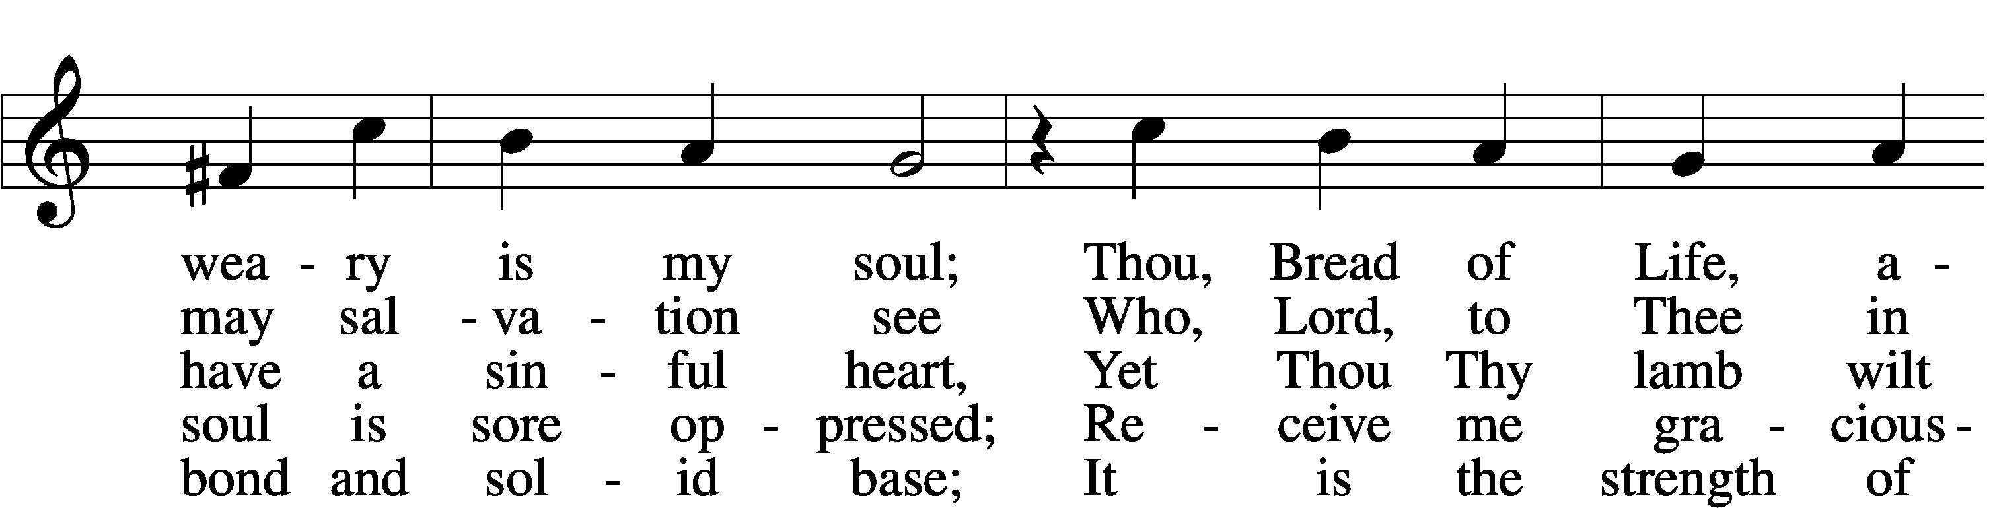
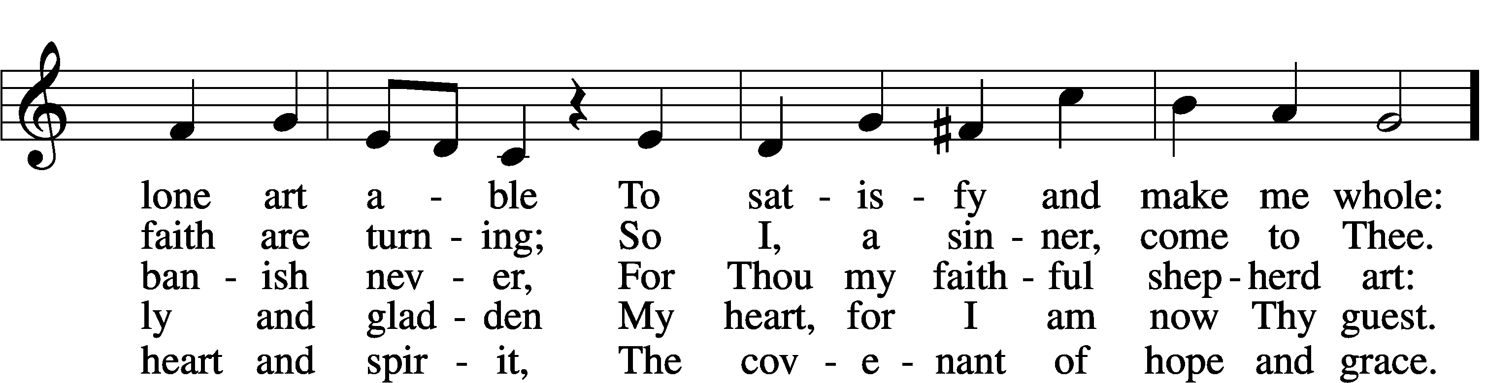
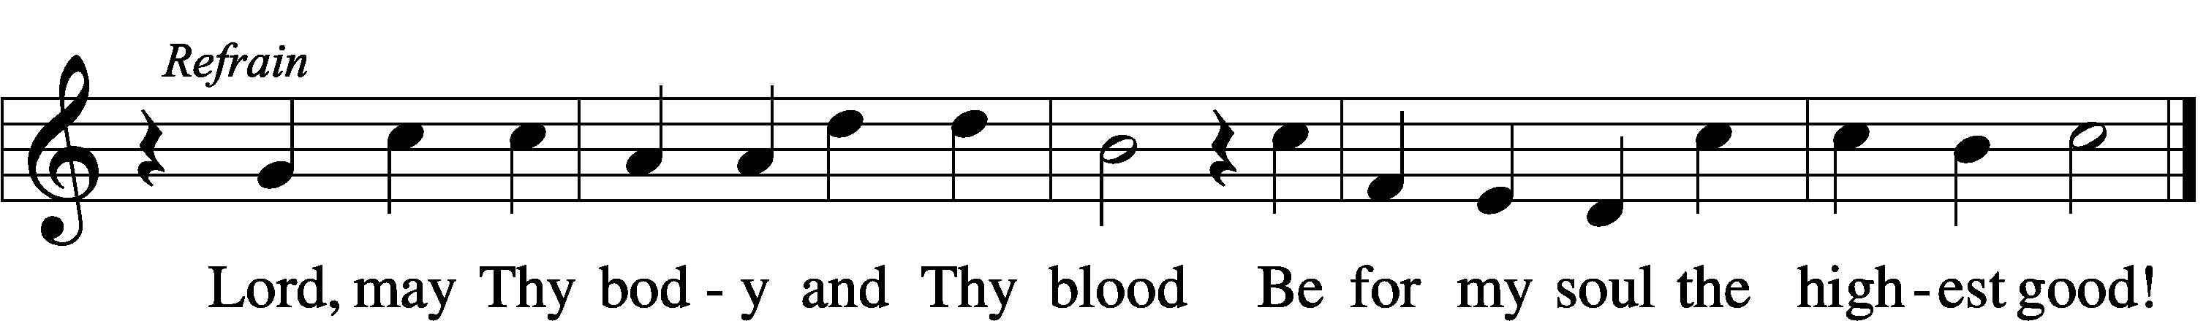

Text: Friedrich Christian Heyder, 1677–1754; tr. The Lutheran Hymnal, 1941, abr.
Tune: Emskirchner Choral-Buch, 1756, Leipzig
Text: © 1941 Concordia Publishing House. Used by permission: LSB Hymn License no. 110005275
Tune: Public domain

809 Great Is Thy Faithfulness
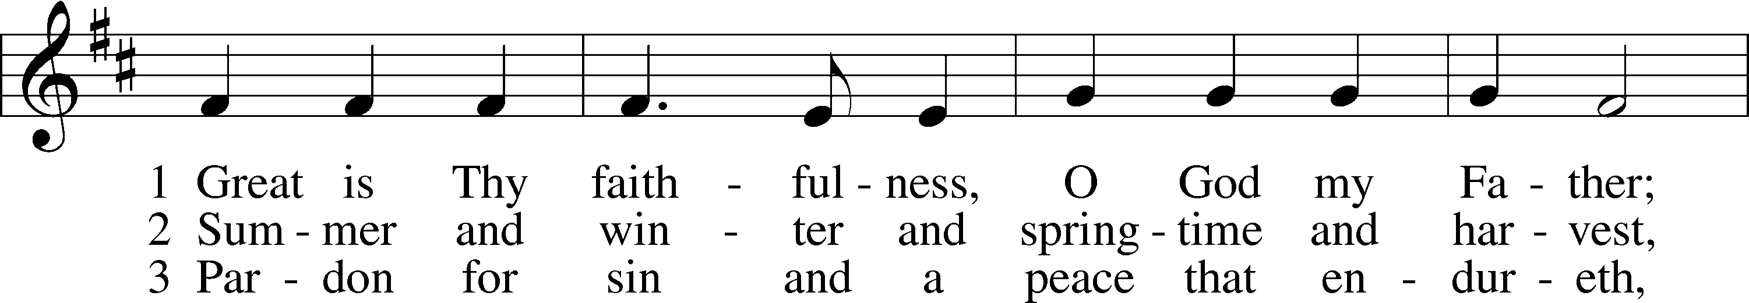
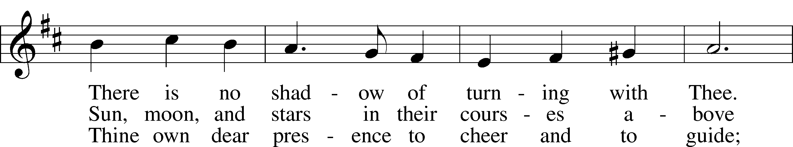
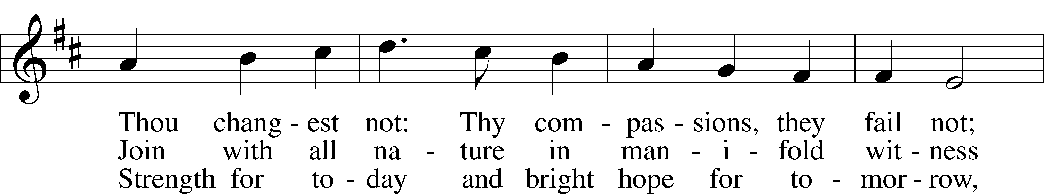
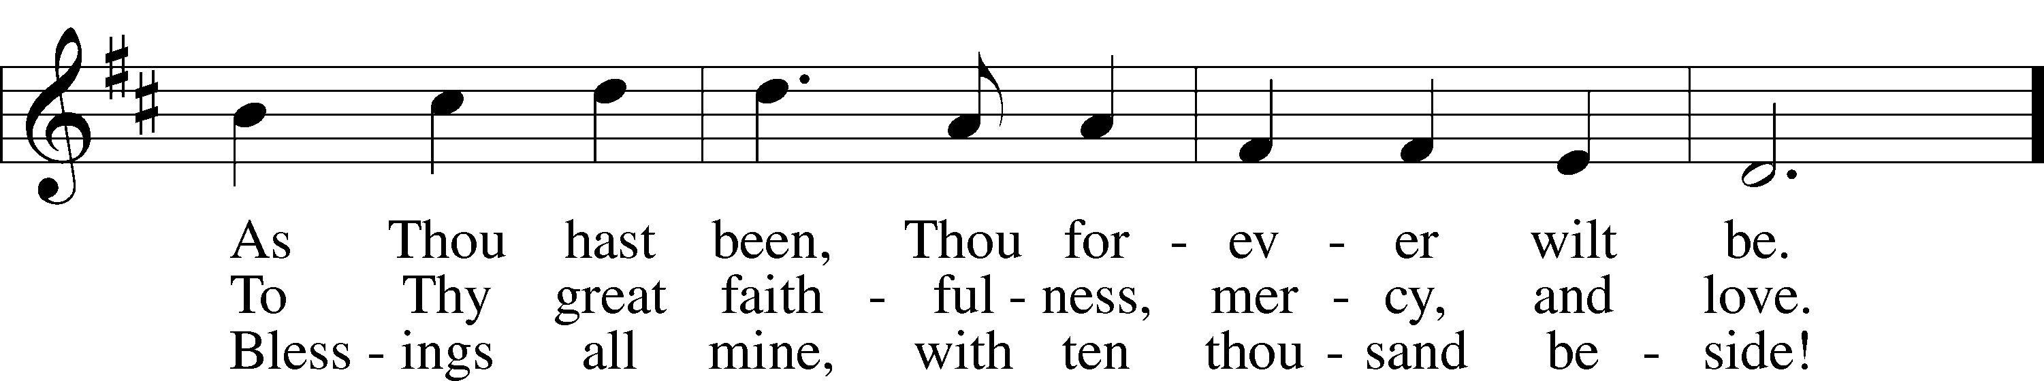
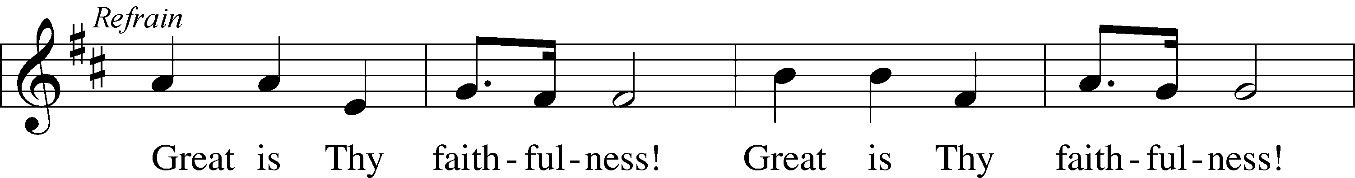
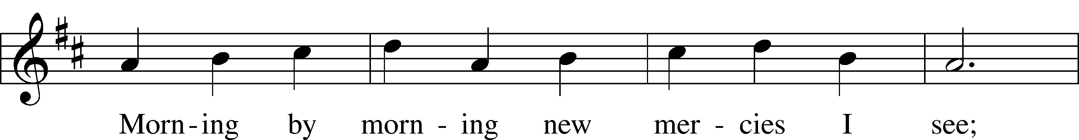
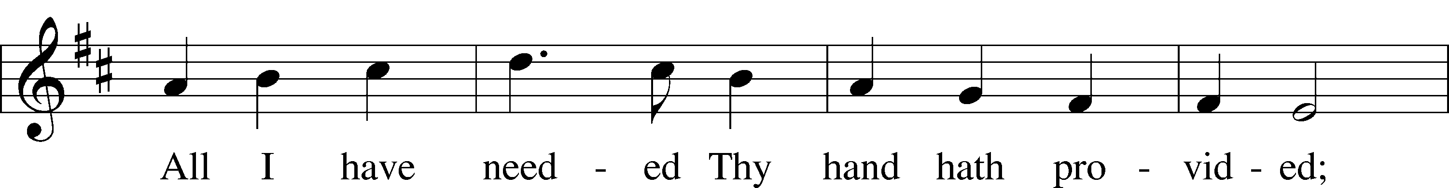
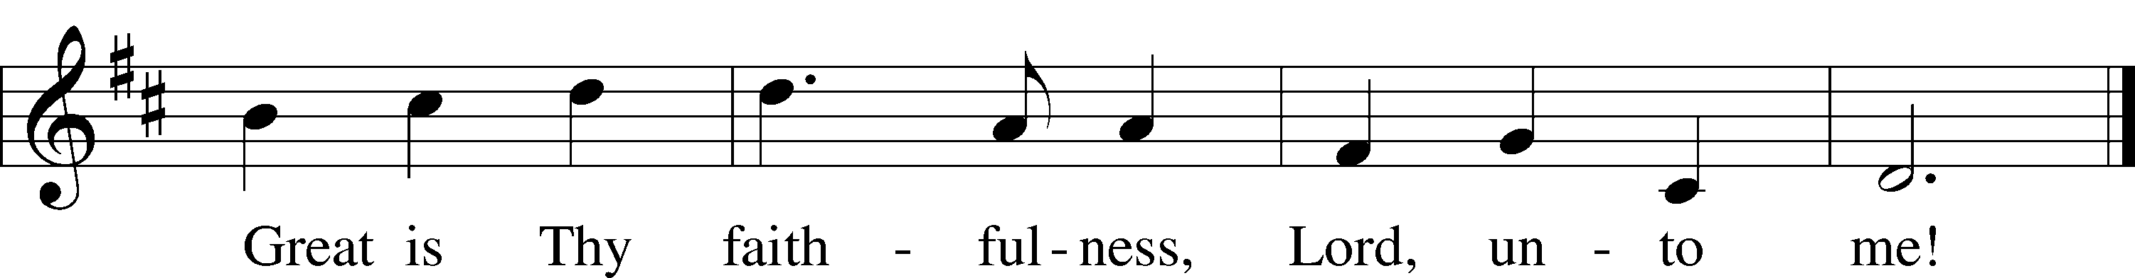

Text: Thomas O. Chisholm, 1866–1960
Tune: William M. Runyan, 1870–1957
Text: Public domain
Tune: Public domain

686 Come, Thou Fount of Every Blessing
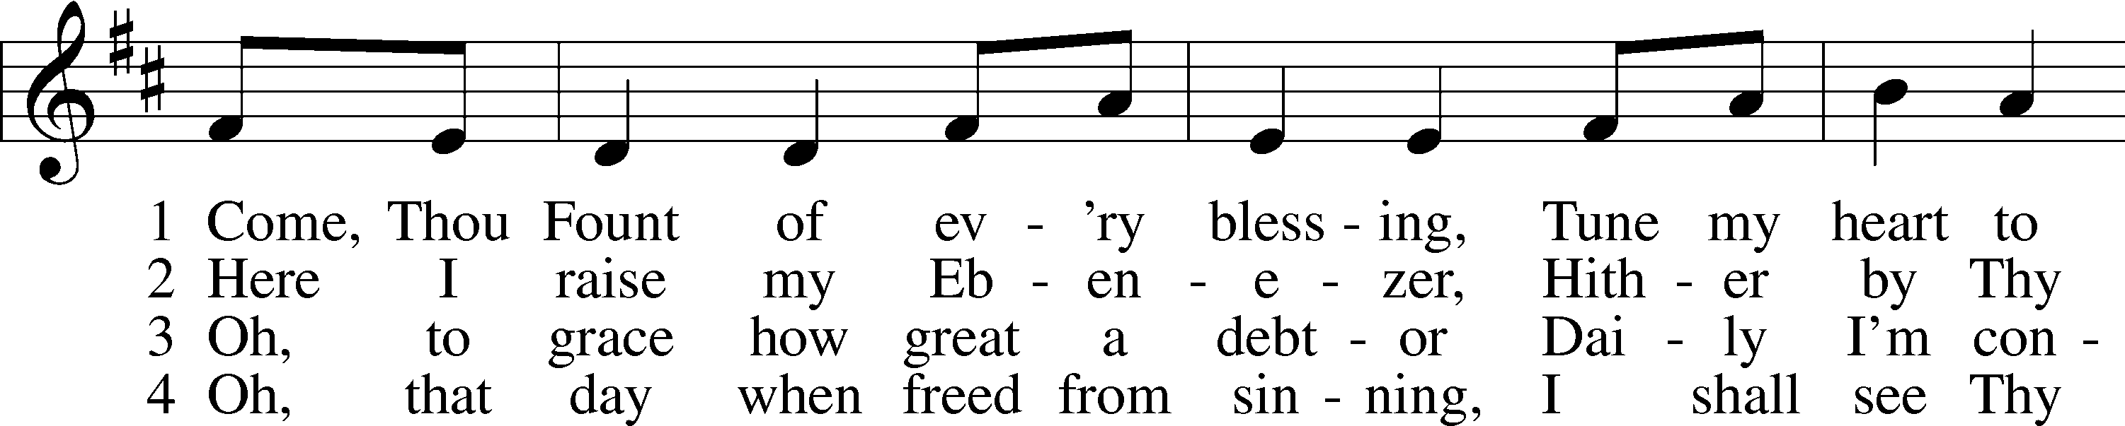
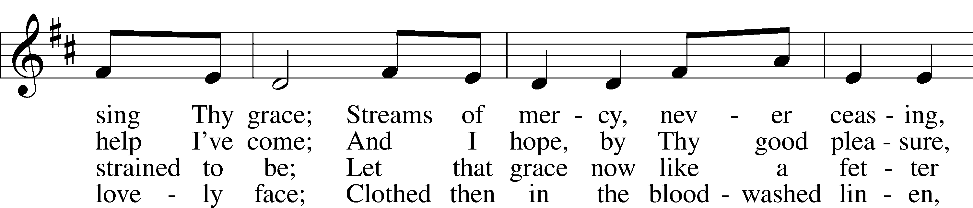
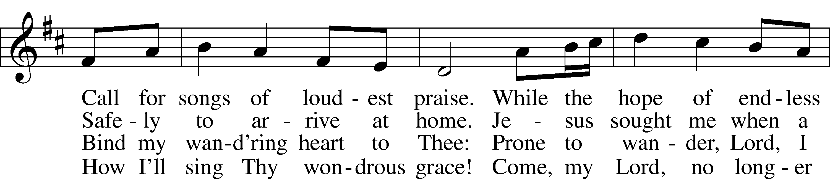
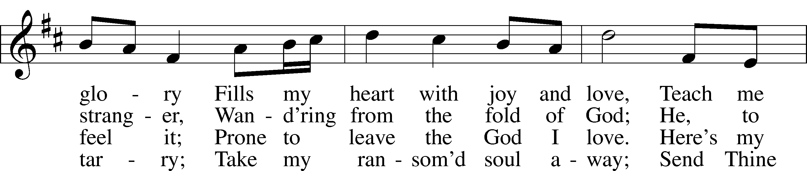
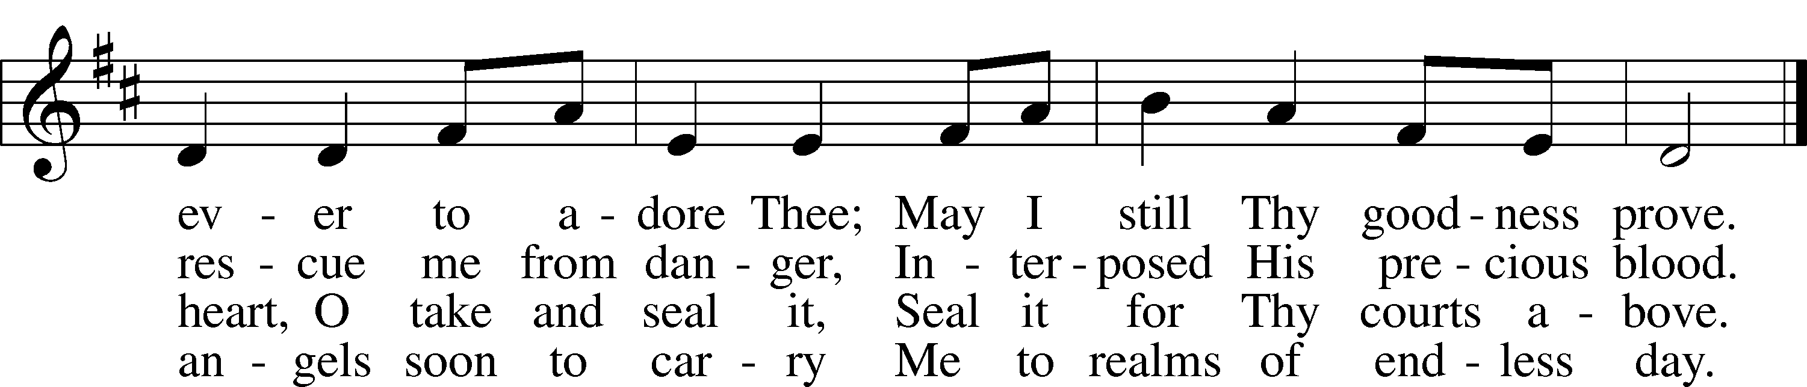

Text: Robert Robinson, 1735–90, alt.
Tune: Repository of Sacred Music, Part Second, 1813, Harrisburg
Text and tune: Public domain

930 All You Works of God, Bless the Lord
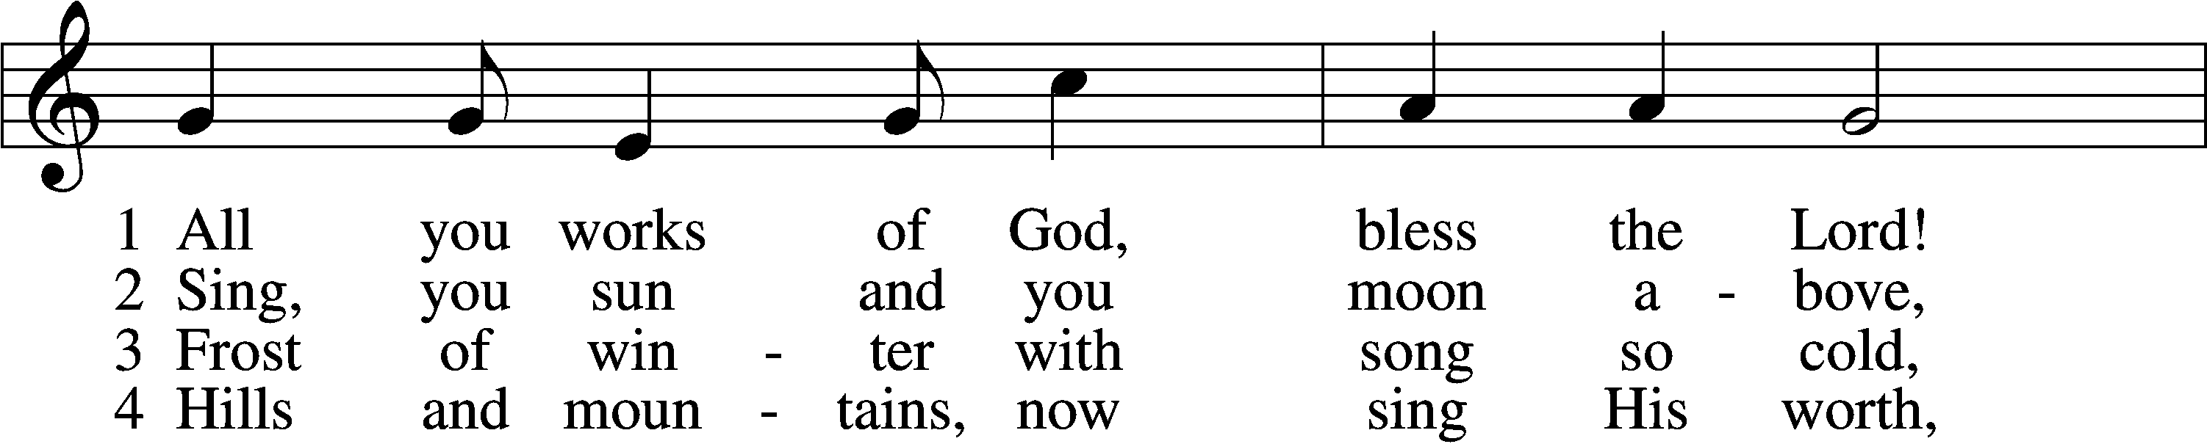
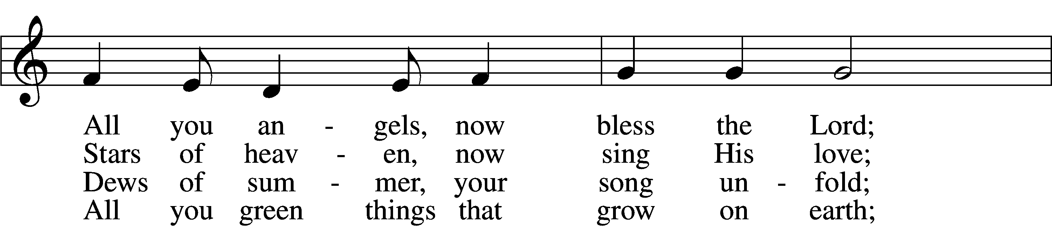
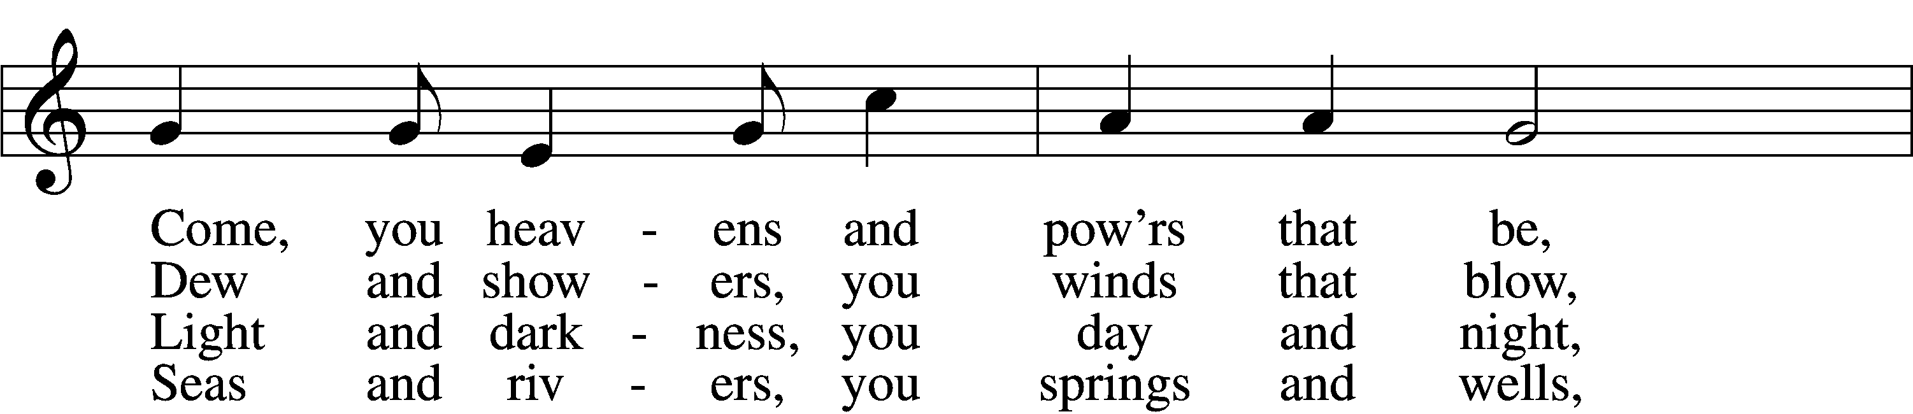
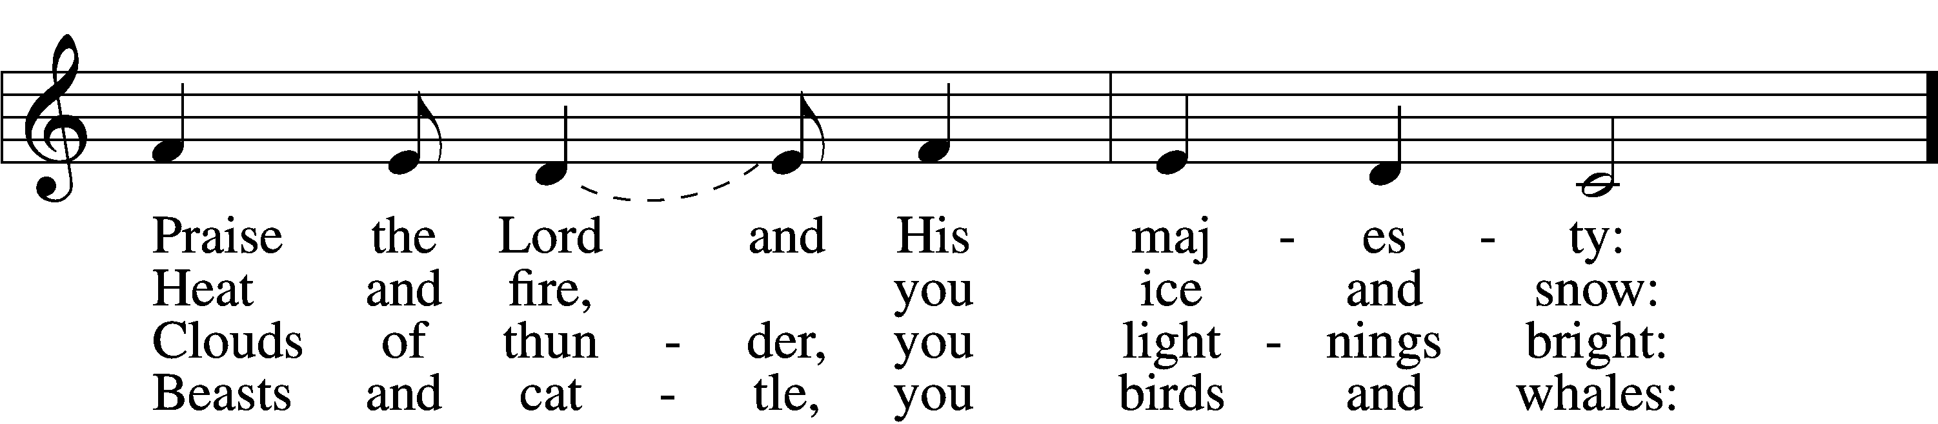
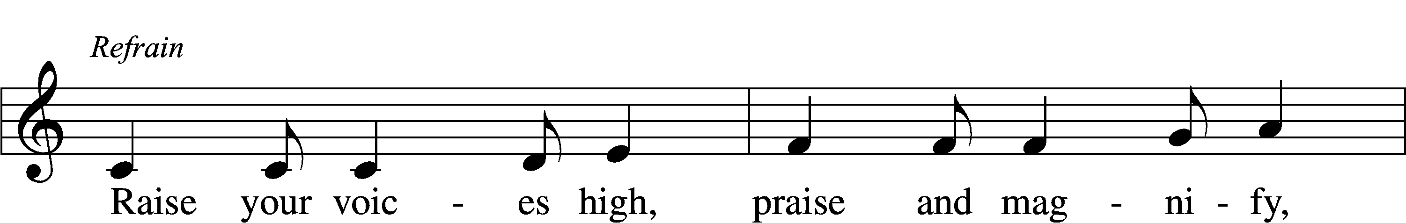
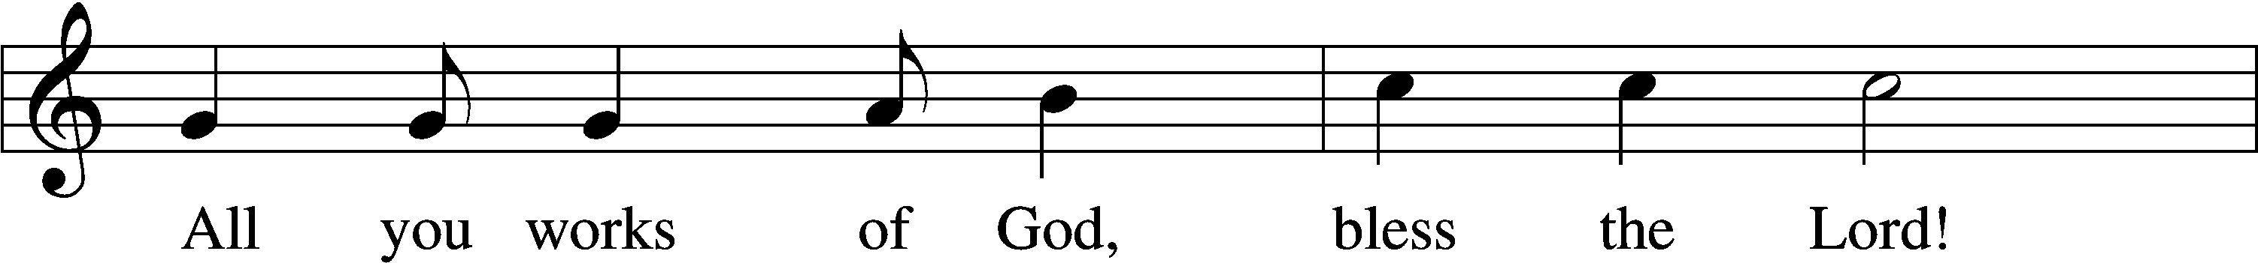
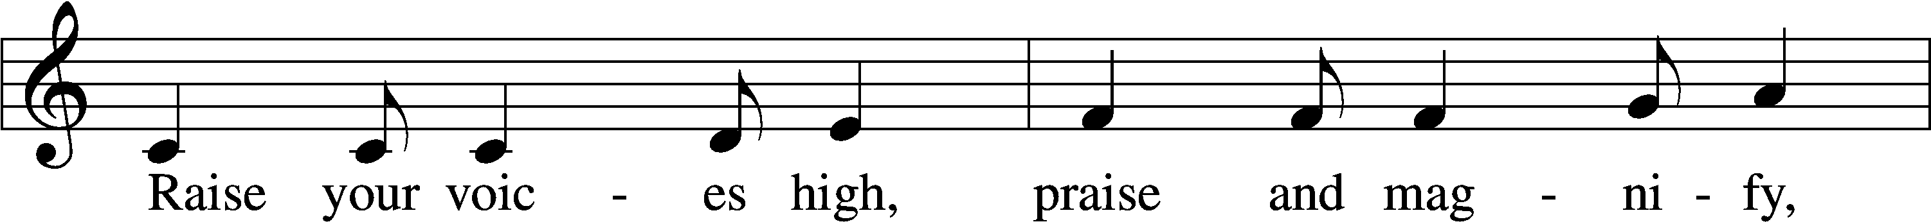
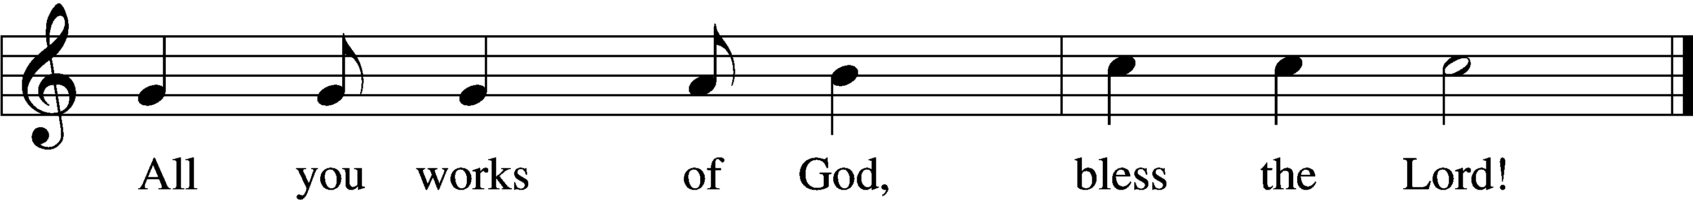

5 Come, humanity, sing along,
Sing, you people of God, a song;
Priests and servants, your Lord now bless,
Join, you spirits and souls at rest: Refrain

6 Bless the Lord, all you pure of heart;
All you humble, His praise impart;
God the Father and Son adore,
Bless the Spirit forevermore! Refrain

Text: Stephen P. Starke, 1955
Tune: Jamaican; adapt. Doreen Potter, 1925–80
Text: © 1995 Stephen P. Starke, admin. Concordia Publishing House. Used by permission: LSB Hymn License no. 110005275
Tune: © 1975 Hope Publishing Co. Used by permission: LSB Hymn License no. 110005275

715 Jesus, Savior, Pilot Me
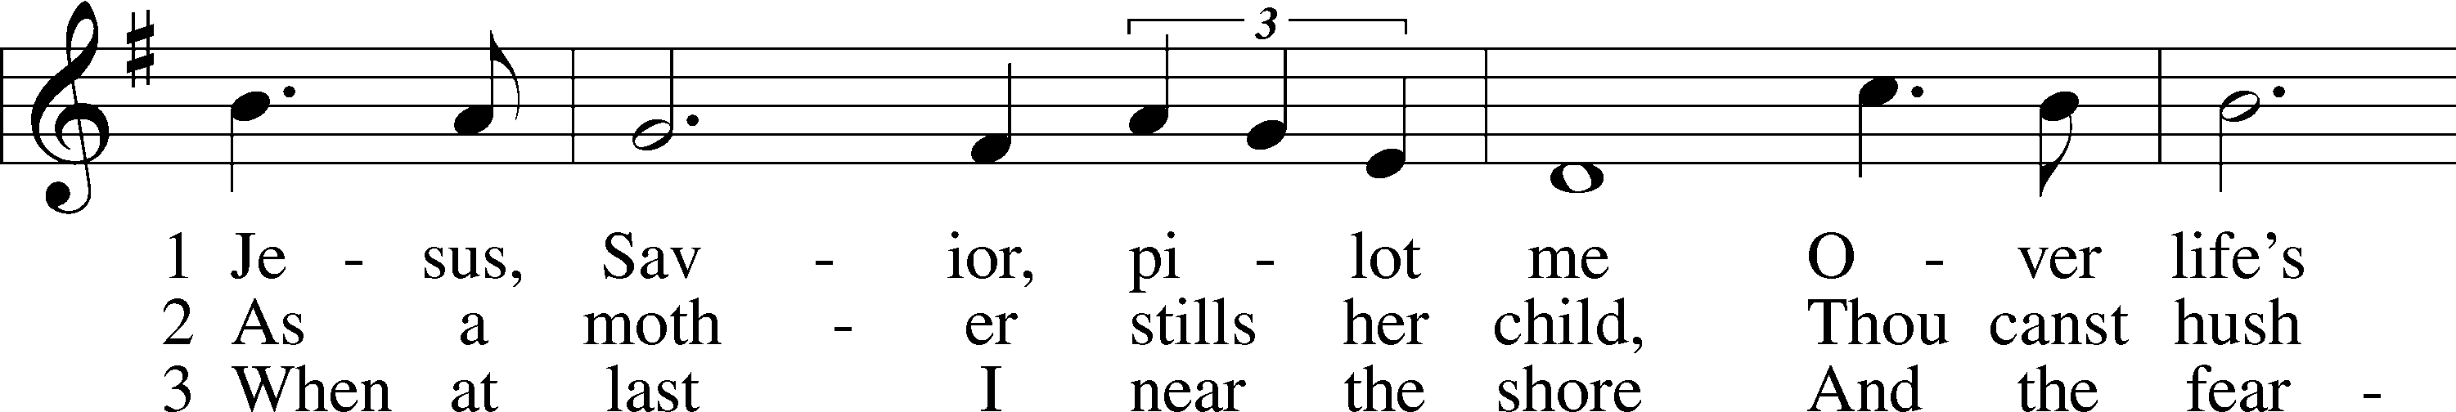
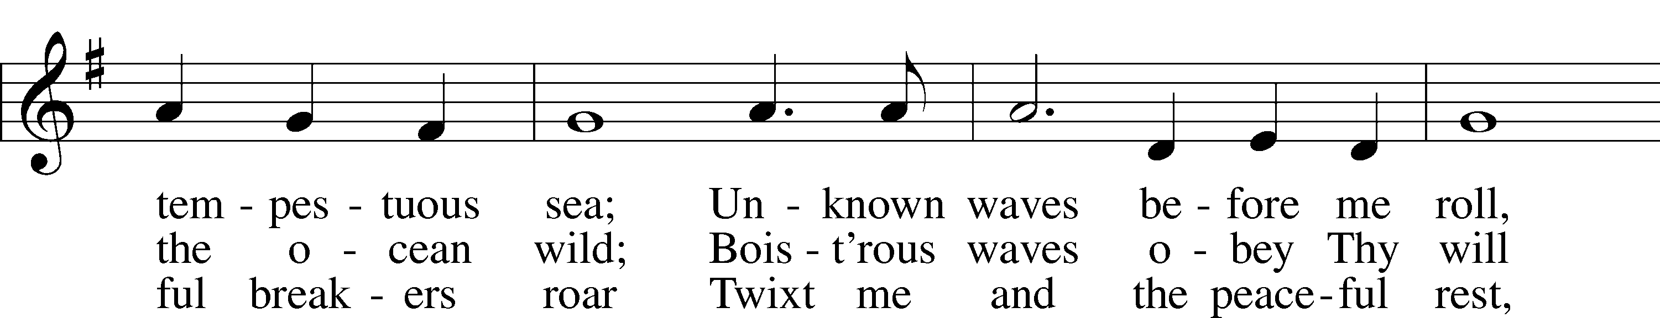
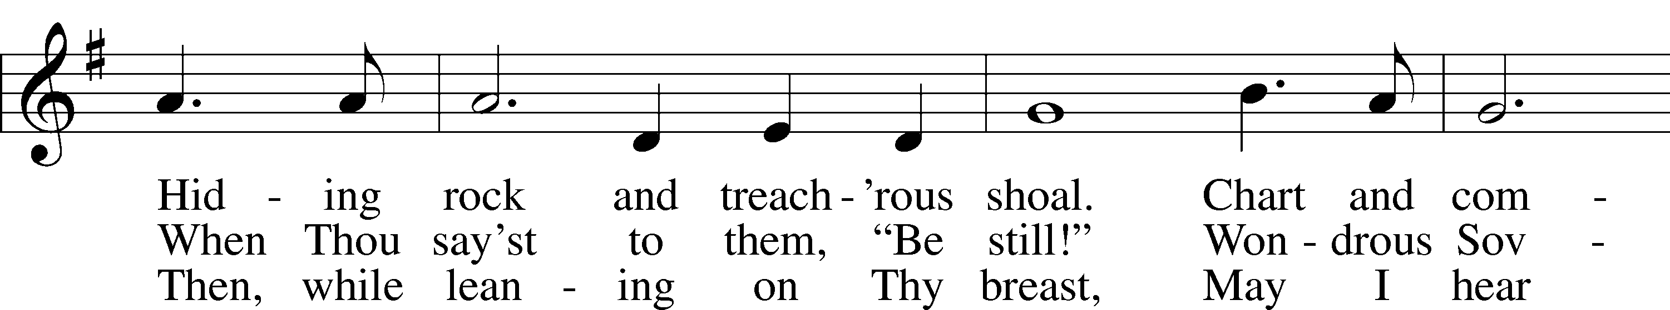
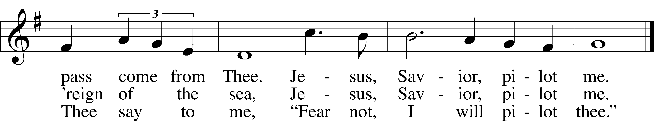

Text: Edward Hopper, 1818–88
Tune: John E. Gould, 1822–75
Text and tune: Public domain

643 Sent Forth by God’s Blessing
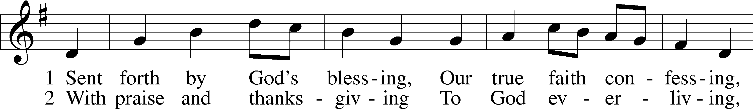
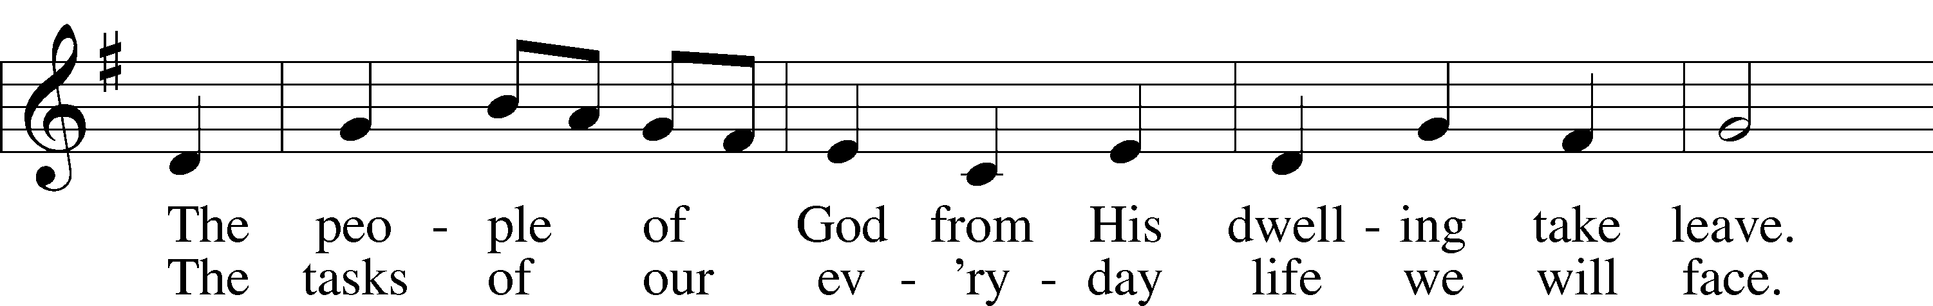
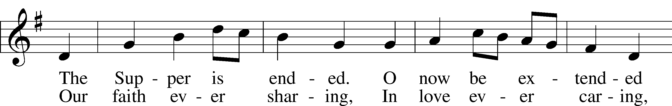
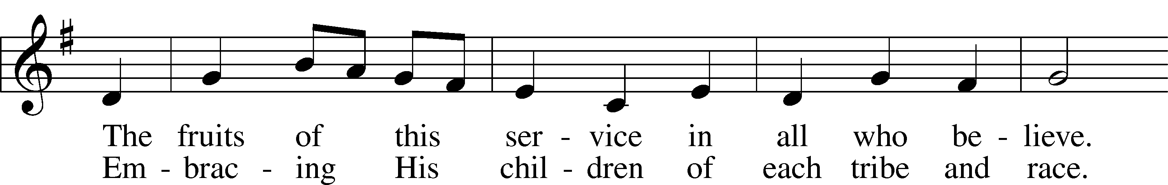
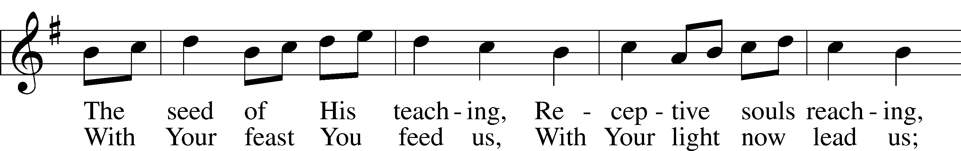
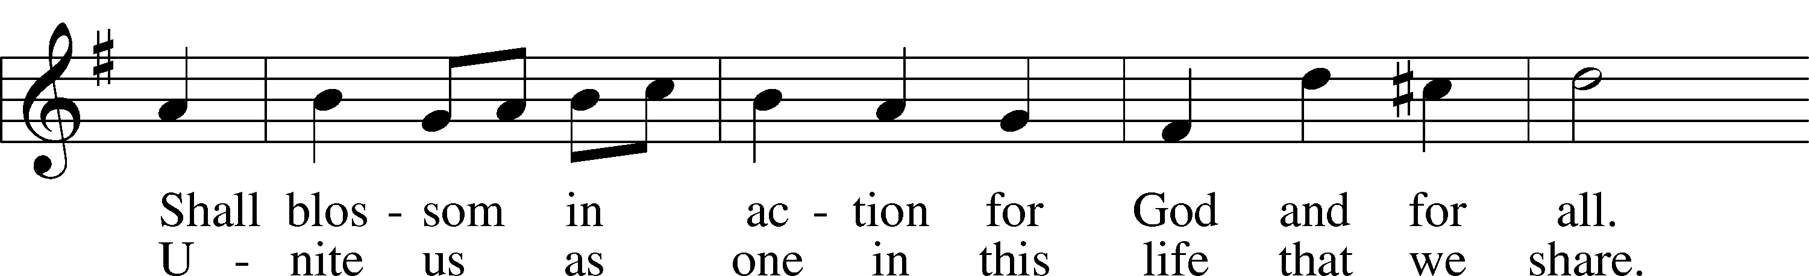
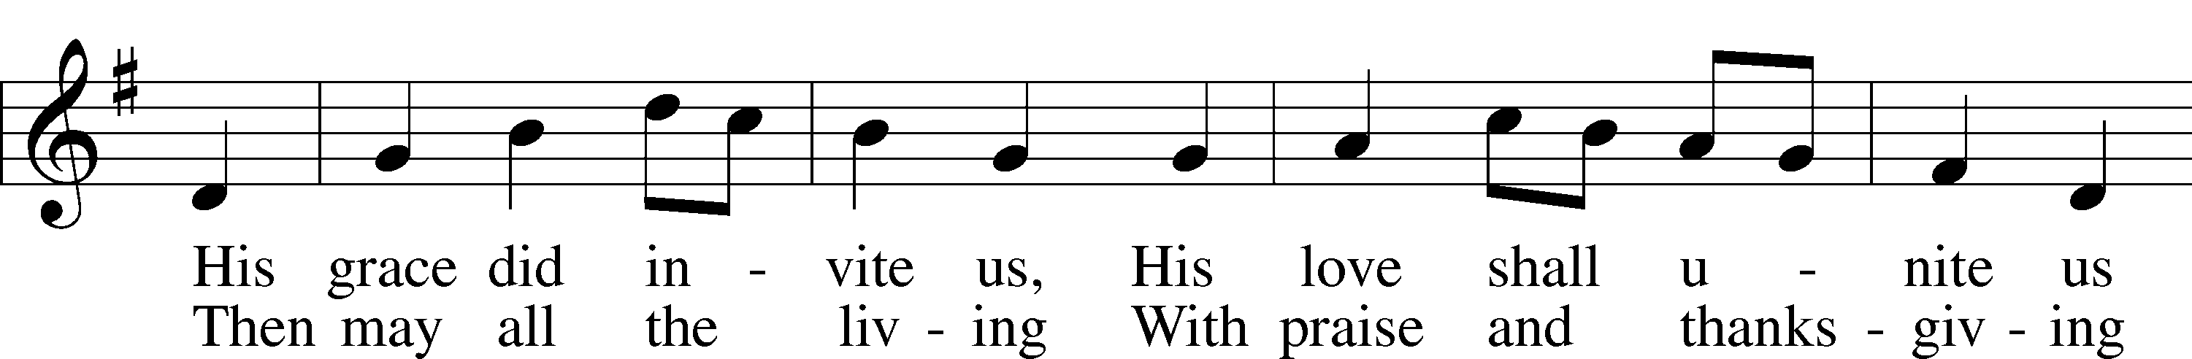
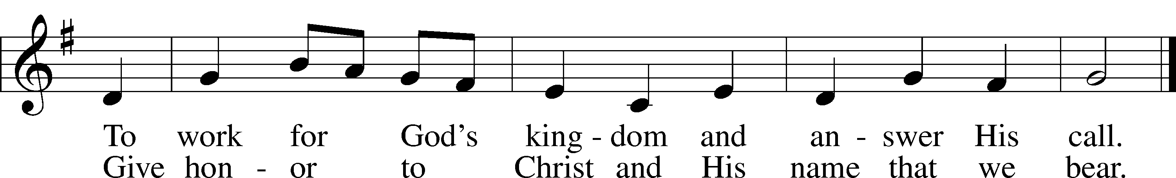

Text: Omer E. Westendorf, 1916–97, alt.
Tune: Welsh
Text: © 1964 World Library Publications. Used by permission: LSB Hymn License no. 110005275
Tune: Public domain

Stand

Thank the Lord LSB 164
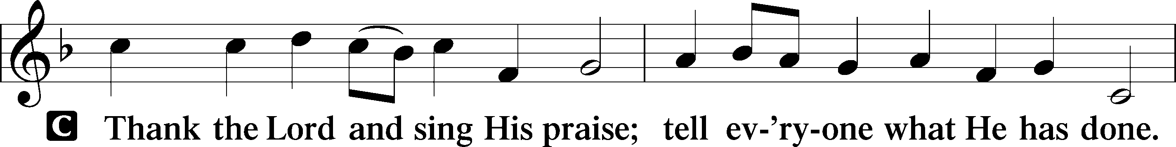
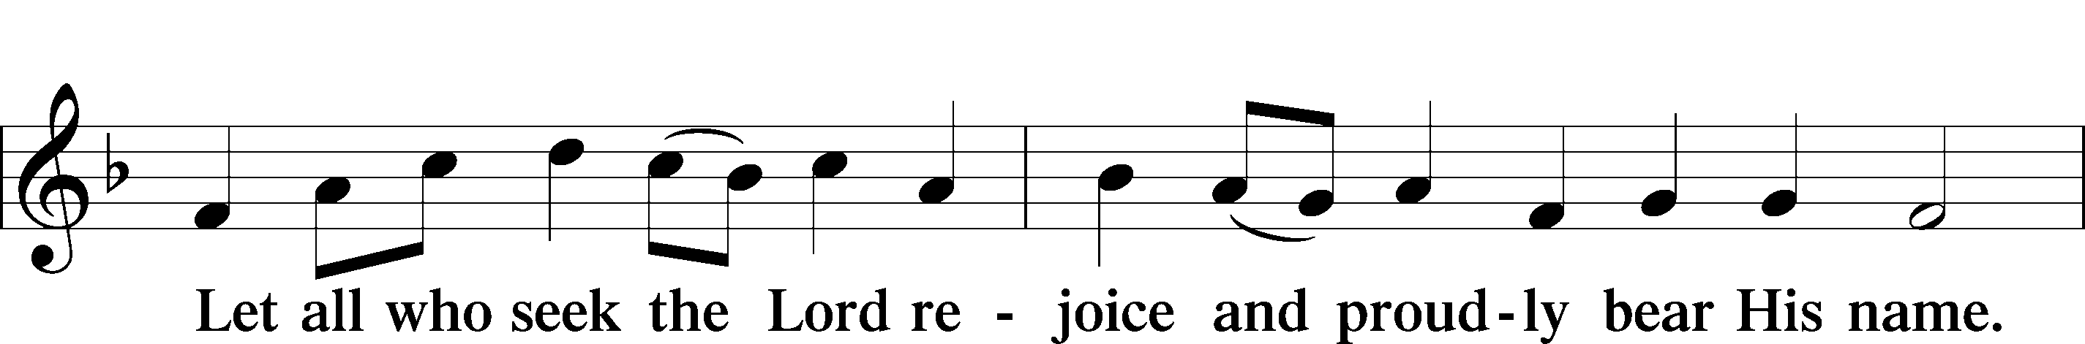
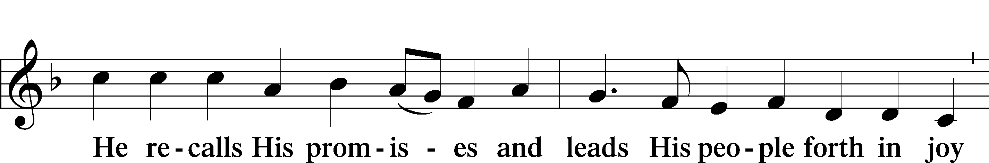
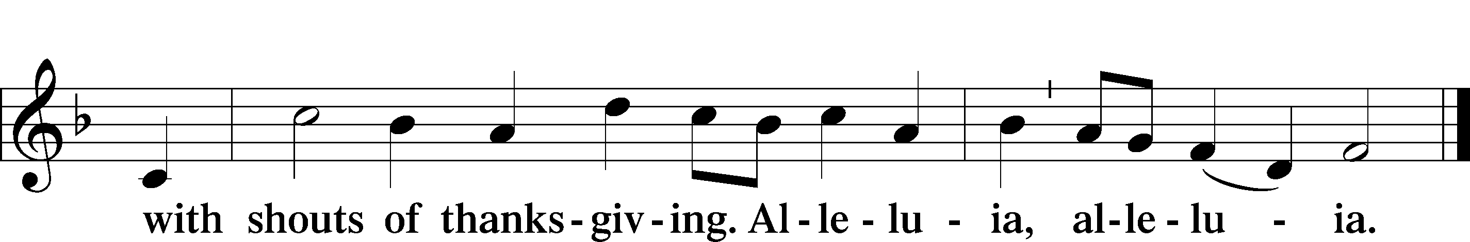

Post-Communion Collect
P Let us pray.
We give thanks to You, almighty God, that You have refreshed us through this salutary gift, and we implore You that of Your mercy You would strengthen us through the same in faith toward You and in fervent love toward one another; through Jesus Christ, Your Son, our Lord, who lives and reigns with You and the Holy Spirit, one God, now and forever.

Benediction LSB 166
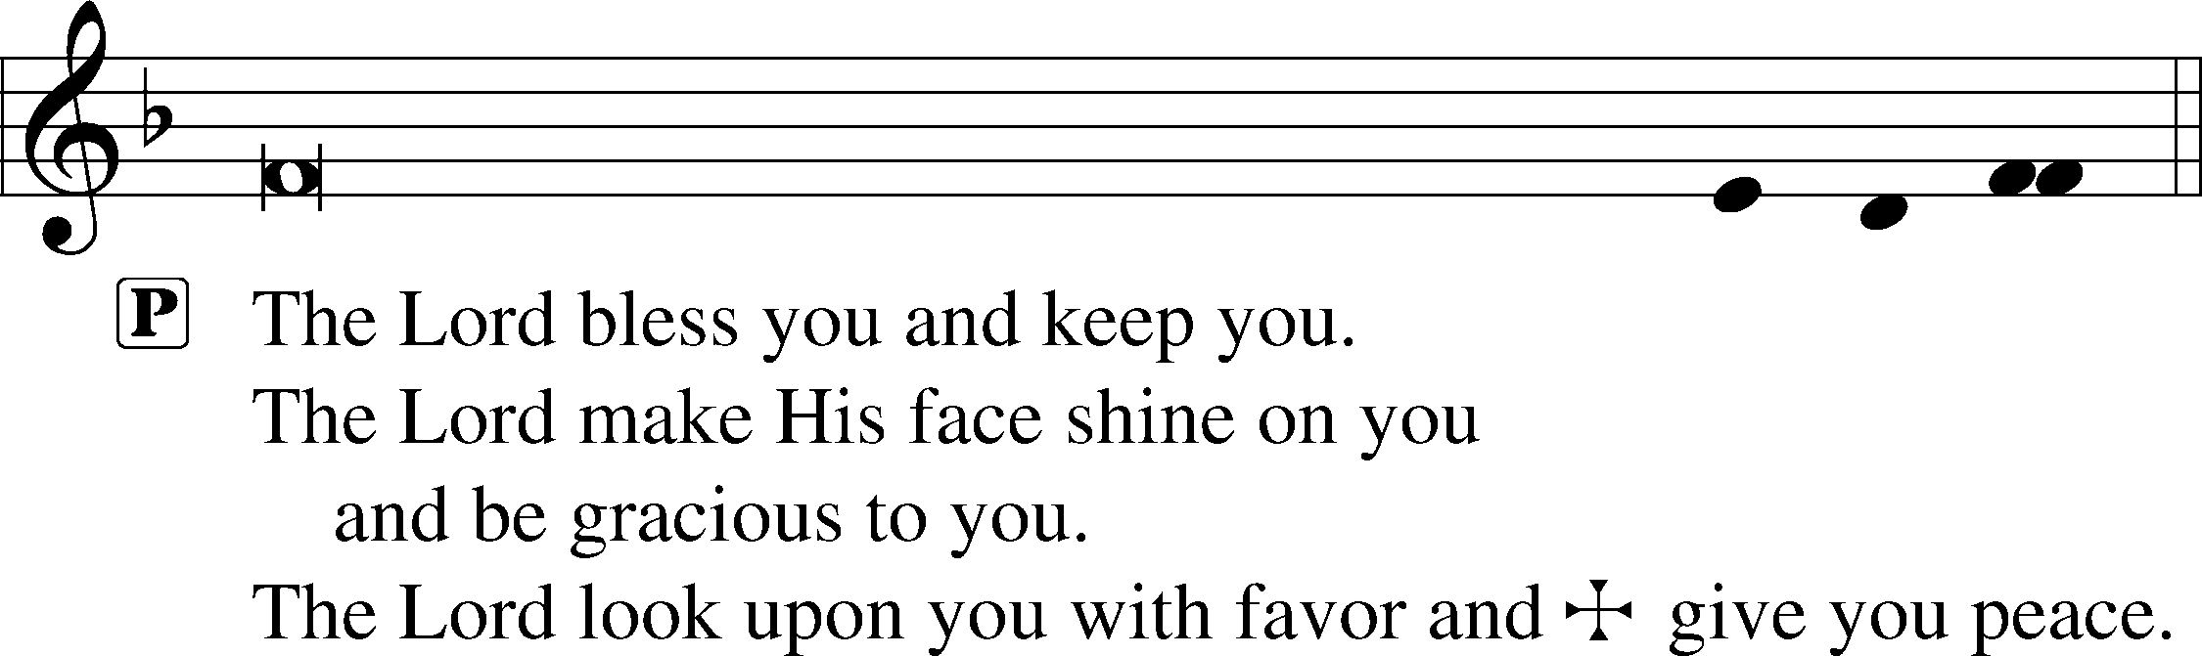

576 My Hope Is Built on Nothing Less (Choir only sings stanza 2.)
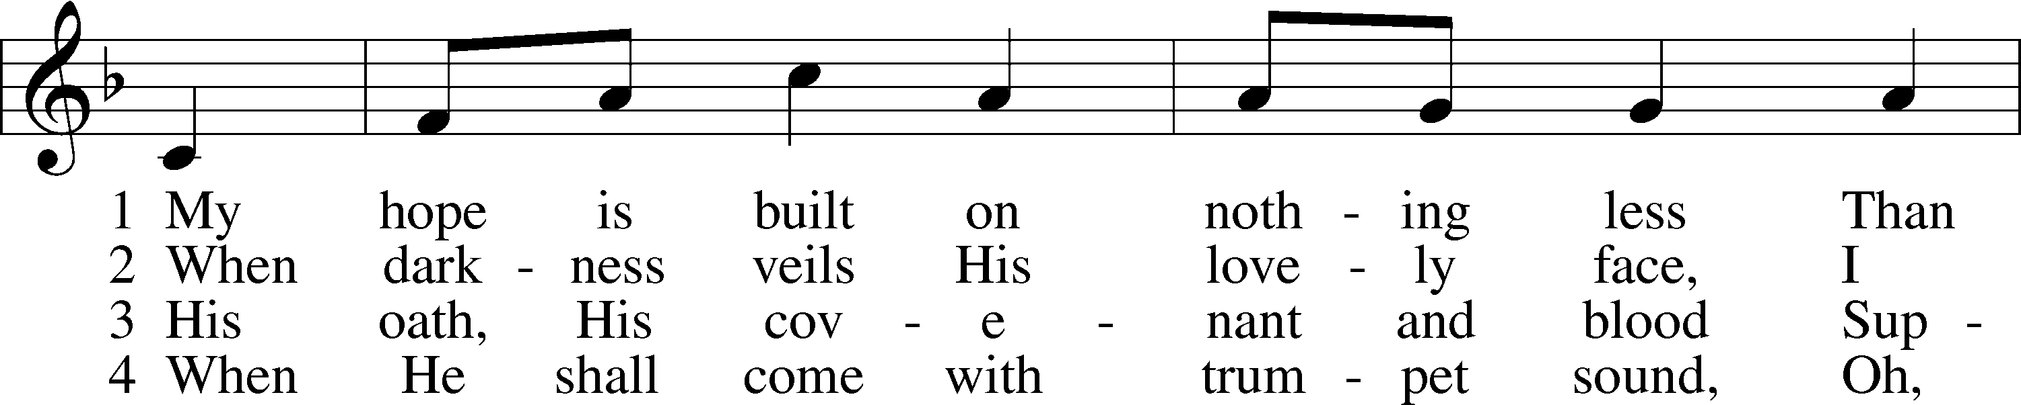
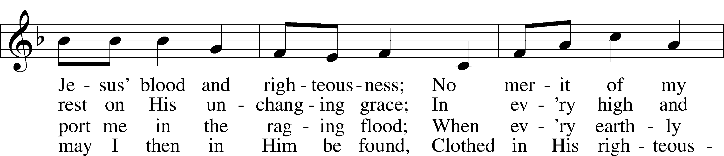
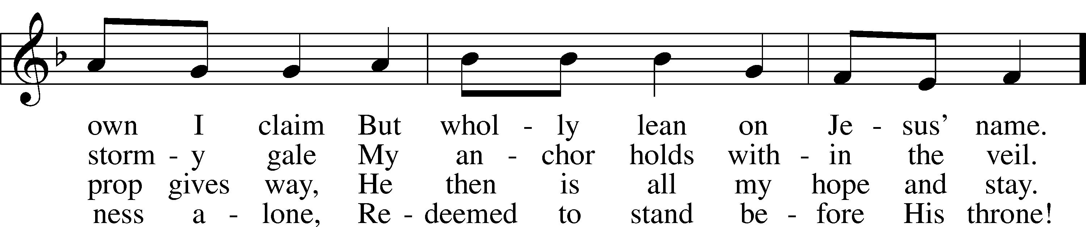
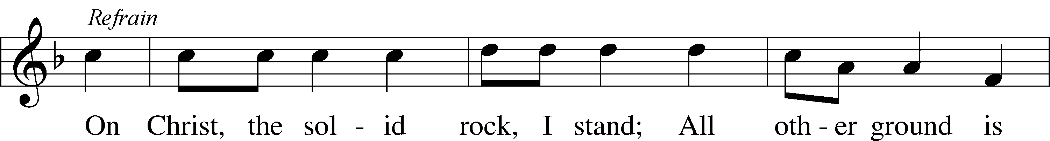
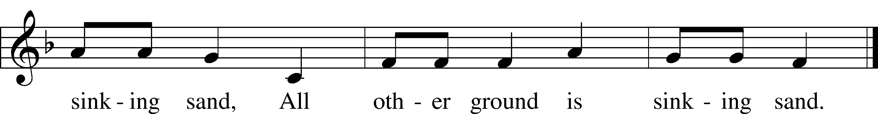

Text: Edward Mote, 1797–1874, alt.
Tune: William B. Bradbury, 1816–68
Text and tune: Public domain
Participants
Proclaimer Rev. Dr. Gerald B. “Jerry” Kieschnick
President Emeritus, The Lutheran Church—Missouri Synod
Past President, Texas District LCMS
Chief Executive Officer, Legacy Deo

Celebrant Rev. Kevin Jennings
Pastor, Mount Olive Lutheran Church, Corpus Christi, Texas
Host Congregation Pastor

Liturgist Rev. Dustin Beck
Pastor, Holy Cross Lutheran Church, Warda, Texas LWML Texas District Junior Pastoral Counselor

Lector Rev. John Heckmann
Pastor, St. Paul Lutheran Church, The Grove, Texas
LWML Texas District Senior Pastoral Counselor

Communion Assistants Pastors from across the Great State of Texas who love the LWML

Organist Mrs. Allison Ulmer
Zion Friedheim Lutheran Church, Decatur, Indiana

Choir Director Mrs. Stephanie Lorenz
St. Paul Lutheran Church, McAllen, Texas

Pre-Service Duets Mrs. Allison Ulmer and Miss Kirryn Wade
St. Paul Lutheran Church, Bishop, Texas

Flautist Mrs. Stephanie Lorenz

Acknowledgments
Divine Service, Setting One from Lutheran Service Book
Unless otherwise indicated, Scripture quotations are from the ESV® Bible (The Holy Bible, English Standard Version®), copyright © 2001 by Crossway, a publishing ministry of Good News Publishers. Used by permission. All rights reserved.
Created by Lutheran Service Builder © 2024 Concordia Publishing House.

"I Will Wait For You” Jordan Kauflin, Keith Getty, Matthew Merker, Stuart Townend ©2018 Getty Music Publishing (Admin. by Capitol CMG Publishing) Reprinted by permission of CCLI License 22166617 + CCLI Streaming License 22167386.

"The Lord is My Salvation" Jonas Myrin, Keith Getty, Kristyn Getty, Nathan Nockels ©2016 Capitol CMG Paragon (Admin. by Capitol CMG Publishing) Reprinted by permission of CCLI License 22166617 + CCLI Streaming License 22167386.

"He Will Hold Me Fast" Ada Ruth Habershon, Matthew Merker ©2013 Getty Music Publishing Reprinted by permission of CCLI License 22166617 + CCLI Streaming License 22167386.

"Jesus Shall Reign" Ed Cash, Isaac Watts, John C. Hatton, Keith Getty, Kristyn Getty ©2018 Capitol CMG Paragon (Admin. by Capitol CMG Publishing) Reprinted by permission of CCLI License 22166617 + CCLI Streaming License 22167386.

"Christ The Sure and Steady Anchor" Matthew Boswell, Matthew Papa ©2015 Getty Music Hymns and Songs (Admin. by Capitol CMG Publishing. Reprinted by permission of CCLI License 22166617
+ CCLI Streaming License 22167386.

